

AI POWERED VIRTUAL JOB INTERVIEW SIMULATOR
PROJECT REPORT
Submitted by
P.JOTHIMANI (622921104304)
A.LINGESVARAN (622921104307)
T.RASAKUMAR (622921104312)
R.RUVENTHIRAN (622921104313)

in partial fulfillment for the award of the degree
of
BACHELOR OF ENGINEERING

IN

COMPUTER SCIENCE ENGINEERING
ANNA UNIVERSITY : CHENNAI - 600 025
APRIL / MAY- 2025
ANNA UNIVERSITY : CHENNAI – 600 025

Bonafide Certificate
Certified that this project report titled “AI POWERED VIRTUAL JOB INTERVIEW SIMULATOR” is the bonafide work of P.JOTHIMANI, A.LINGESVARAN, T.RASAKUMAR,R.RUVENTHIRAN who carried out the research under my supervision. Certified further, that to the best of my knowledge the work reported here in does not form part of any other project report or dissertation on the basis of which a degree or award was conferred on an earlier occasion on this or any other candidate.

SIGNATURE SIGNATURE
Mrs. R.MURUGASELVI.,M.E., Dr.S.SATHYAMOORTHY.,Ph.D.,
PROFESSOR AND HEAD ASSISTANT PROFESSOR
Department of CSE Department of CSE
T.S.M Jain College of Technology T.S.M Jain College of Technology
Melur-606 201. Melur-606 201.

Submitted for the Project Viva-Voce examination held on ___________________

Internal Examiner External Examiner

ACKNOWLEDGEMENT

First of all, I am grateful to The Almighty God for establishing me to complete this project.
I would like to extend my heartfelt gratitude to our respected
Chairman Mr. T. MANOHAR KUMAR SURANA B.COM.,and I deliver my sincere thanks to our Secretary Mr. T. ASHOK KUMAR B.E., M.B.A. who is the guiding light for all the activities in our college
I wish to express my sincere thanks to our adored
Principal Dr. T.ESWARAN, M.B.A,GATE,M.E., PH.D., for providing me with all the necessary facilities.
The great full thank for Head of the Department Mrs.R.MURUGASELVI.ME., Department of Computer Science and Engineering, T.S.M. Jain College of Technology, Melur.

I place on record, our sincere gratitude to Dr.S.SATHYAMOORTHY.,Ph.D., Assistant Professor, Department of Computer Science and Engineering, T.S.M. Jain College of Technology, Melur for his guidance in my project

I take this opportunity to convey my sincere thanks to all the teaching staff and non-teaching staff of Department of Computer Science and Engineering for their help and encouragement. I also thank my parents for the unceasing support and encouragement

JOTHIMANI.P
LINGESVARAN.A
RASAKUMAR.T
RUVENTHIRAN.R
THANKS TO ALL
CHAPTER NO | TITLE | PAGE NO
 | ABSTRACT | Iv
 | LIST OF FIGURES | Viii
 | LIST OF ABBREVATIONS | x
CHAPTER-1
1. | INTRODUCTION | 3
 | - OVERVIEW | 4
 | - TECHNOLOGY THE TOPIC | 5
 | - ADVANTAGES OF INTRODUCTION  - APPLICATION  - PROBLEM STATEMENT  - VITRUAL JOB INTERVIEW  - LEVEL OF VIRTUAL JOB INTERVIEW | 6  7  8  10
CHAPTER-2
2. | LITEARTURE REVIEW | 12
 | - TITLE  - TITLE  - TITLE  - TITLE  - TITLE  - TITLE  - TITLE  - TITLE  - TITLE  - TITLE | 12  13  14  15  16  17  18  19
CHAPTER-3 | 3. SYSTEM ANALYSIS | 21
 | 3.1EXISTING SYSTEM  3.1.1 DISADVANTAGES | 21  22
 | 3.2 PROPOSED SYSTEM | 22
 | 3.2.1 ADVANTAGES | 23
 | 3.3 SYSTEMREQUIREMENTS | 23
 | 3.3.1 HARDWARE REQUIREMENT:-  3.3.2 SOFTWARE REQUIREMENT:-  3.3.3 SOFTWARE DESCRIPTION:- | 23  24  24
CHAPTER - 4
4. | SYSTEM DESIGN | 26
 | 4.1 DATA FLOW DIAGRAM | 26
 | 4.2 UML DIAGRAMS  4.2.1 USE CASE DIAGRAM  4.2.2 CLASS DIAGRAM  4.2.3 SEQUENCE DIAGRAM  4.3.4 ACTIVITY DIAGRAM | 27  27  27  28  30
CHAPTER - 5
5.  CHAPTER - 6 | SYSTEM ARCHITECTURE  5.1 SYSTEM ARCHITECTURE  5.2 SYSTEM ARCHITECTURE DESCRIPTION  5.3 MODAL DESIGN  5.3.1 GPT-4 CLASSIFICATION | 31  31  31  32
6.  CHAPTER - 7 | SYSTEM IMPLEMENTATION  6.1 MODULE LIST  6.2 MODULE DESCRIPTION | 34  34  34
7.  CHAPTER - 8 | SYSTEM TESTING  7.1 TESTING OBJECTIVE  7.2 TESTING METHOD | 38  38  39
8. | 8.1 CONCLUSION  8.2 FUTURE ENHANCEMENT | 41  42
 | REFERENCES | 71

ABSTRACT

Brain tumors is the most common and aggressive leading to a very short life expectancy in their highest grade. Magnetic resonance imaging (MRI) is a widely used imaging technique to assess these tumors, but the large amount of data produced by MRI prevents manual segmentation in a reasonable time. So, automatic and reliable segmentation methods are required. The large spatial and structural variability among brain tumors make automatic segmentation a challenging problem. Tumor part in an MRI image has high intensity when compared to other tissues in a brain image. First process in any medical image processing is to reduce the noise artifacts that are caused due to patient’s motion and other external factors and after removing the general artifacts segmenting the tumor is the most important process in automatic tumor detection and also investigated the use of intensity normalization as a pre-processing step, which though not common in CNN-based segmentation methods, proved together with data augmentation to be very effective for brain tumor segmentation in MRI images. The result shows that patch-wise approaches trained on a balanced training set of tumor and non-tumor patches delivers strong segmentation with mean dice score of 0.86. This results from transfer learning models pre-trained on the BraTS dataset to other neuroimaging datasets is promising but requires further work.

ABSTRACT
This paper introduces an innovative AI-powered platform designed to optimize and secure the candidate evaluation process in recruitment, education, and certification. The platform utilizes GPT-4’s advanced natural language processing capabilities to analyze uploaded PDF resumes, generating personalized, concise questions that are specifically tailored to each candidate’s qualifications, skills, and experiences. This approach ensures a more targeted and efficient evaluation, allowing recruiters and educators to focus on the most relevant aspects of the candidate's profile. In addition to automated resume parsing, the platform integrates real-time facial recognition technology for identity verification, preventing impersonation and ensuring the integrity of the process. In the event of any anomalies or suspicious behavior, the system sends instant alerts to recruiters, further enhancing security. The platform’s dynamic questioning capability adapts to candidates’ responses, offering instant feedback and refining subsequent questions based on previous answers. This creates an interactive and engaging assessment process that not only evaluates candidates more comprehensively but also improves their experience by providing personalized feedback. By combining these advanced features—automated resume parsing, dynamic questioning, and biometric security—the platform provides an efficient, secure, and user-friendly solution that enhances the accuracy and trustworthiness of candidate evaluations. This AI-powered system is highly suitable for applications in recruitment, education, and certification, offering a transformative approach to candidate assessment that benefits both candidates and recruiters alike.

CHAPTER 1
INTRODUCTION
The concept presented here introduces an innovative AI-powered platform that aims to revolutionize traditional evaluation methods in recruitment and certification processes. In an era where efficiency and security are paramount, this platform offers a modern solution that addresses the challenges faced by both candidates and recruiters.The user journey begins with a straightforward registration or login process, allowing candidates to easily access the platform. Once logged in, users can upload their resumes in PDF format, which is a common and widely accepted file type. The platform leverages the advanced capabilities of GPT-4 technology to meticulously analyze the content of each resume. This analysis is not merely superficial; it generates personalized and concise questions tailored to the individual candidate’s background, skills, and experiences. This targeted approach ensures a streamlined evaluation process, allowing recruiters to focus on the most relevant aspects of each candidate’s qualifications.In addition to its intelligent resume parsing capabilities, the platform incorporates a robust real-time facial verification system. This feature significantly enhances security by detecting anomalies that may indicate fraudulent activity, such as impersonation. When irregularities are identified, the system promptly sends instant alerts to administrators, enabling them to take immediate action and maintain the integrity of the evaluation process.By combining intelligent resume analysis, dynamic questioning, and biometric monitoring, this AI-powered platform delivers a smart, secure, and user-friendly solution tailored to the needs of modern recruitment and certification. It not only simplifies the evaluation process but also fosters a more engaging experience for candidates, ultimately transforming how organizations assess talent in today’s competitive landscape. This innovative approach positions the platform as a leader in the future of candidate evaluation.

  - OVERVIEW
This AI-powered platform is designed to transform traditional recruitment and certification processes by offering an efficient, secure, and personalized candidate evaluation experience. In an era where time, accuracy, and security are crucial, this platform addresses the challenges faced by both candidates and recruiters with advanced technological solutions.The process begins with a simple registration or login, where candidates upload their resumes in PDF format. Using GPT-4, the platform meticulously analyzes the content of each resume, extracting key information such as skills, qualifications, and experiences. Based on this analysis, the system generates tailored, concise questions relevant to each candidate's background. This dynamic approach ensures that recruiters focus on the most pertinent aspects of a candidate's qualifications, making the evaluation process more targeted and efficient.In addition to resume analysis, the platform incorporates a robust real-time facial recognition system, enhancing security by verifying the identity of the candidate during the evaluation. This feature prevents fraud, such as impersonation, by continuously scanning the candidate’s face. If any anomalies are detected, the system sends instant alerts to administrators, ensuring the integrity of the process is maintained.The platform’s dynamic questioning adapts in real-time to candidates' responses, offering instant feedback that helps candidates refine their answers and present themselves more effectively. By combining intelligent resume parsing, personalized questioning, and biometric monitoring, this AI-powered platform not only streamlines the recruitment and certification process but also creates a more engaging and secure experience for both candidates and recruiters.Ultimately, this innovative platform revolutionizes how talent is evaluated, providing a smarter, more efficient solution for modern-day recruitment and assessment needs.

  - TECHNOLOGY THE TOPIC
GPT-4
The concept of the AI-powered platform described here leverages the capabilities of GPT-4 to revolutionize traditional evaluation methods in recruitment and certification. In this platform, GPT-4 plays a crucial role in analyzing candidate resumes and generating personalized questions based on the information extracted from these resumes.When a candidate uploads their resume in PDF format, the platform uses GPT-4's natural language processing (NLP) abilities to read and comprehend the content. GPT-4 analyzes the candidate’s skills, work experiences, qualifications, and educational background to generate specific questions tailored to their profile. This personalized approach streamlines the evaluation process, allowing recruiters to focus on the most relevant aspects of the candidate’s qualifications. It ensures that the questions asked during the interview or assessment are meaningful, making the evaluation process more efficient and relevant to the candidate’s expertise.Furthermore, the platform uses real-time facial recognition technology to verify the identity of the candidate during the evaluation process. This ensures security and prevents fraud, such as impersonation, by continually scanning the candidate’s face. If any discrepancies are detected, the system instantly alerts recruiters, maintaining the integrity of the process.Additionally, the dynamic nature of the platform’s questioning system is powered by GPT-4, which adapts questions in real-time based on the candidate’s responses. As candidates answer, the system tailors subsequent questions to probe deeper into their qualifications or clarify their answers. This dynamic interaction provides a more comprehensive and engaging evaluation process.By integrating GPT-4 for intelligent resume analysis, real-time questioning, and biometric security, this platform provides a more efficient, secure, and personalized candidate evaluation experience, ultimately transforming recruitment and certification processes.
  - ADVANTAGES OF INTRODUCTION
Personalized Evaluation: Tailored questions based on resume analysis ensure focused and relevant assessments.
Security: Real-time facial recognition prevents fraud and maintains the integrity of the process.
Dynamic Questioning: Adaptable questions provide real-time feedback, enhancing candidate responses.
Efficiency: Automates resume parsing and question generation, reducing manual effort and speeding up recruitment.
Improved Candidate Experience: Personalized and engaging assessments lead to a better candidate experience.
Comprehensive Assessment: Evaluates both technical and soft skills for a well-rounded view of candidates.
  - APPLICATION

1. Recruitment and Hiring Platforms:
Application: The platform can be integrated into job boards or recruitment agencies to streamline the hiring process. By automating resume analysis and generating tailored interview questions, recruiters can more efficiently assess candidates' skills and qualifications.

2. Online Certification and Skill Assessments:
Application: Educational institutions or certification bodies can use this platform to assess candidates for certification exams or courses. The system can evaluate candidates' knowledge and skills dynamically, providing tailored tests based on their resumes or pre-assessment data.

3. Freelancer Platforms:
Application: Freelance marketplaces can integrate this platform to assess the skills of freelancers. By analyzing resumes and portfolios, the system can generate personalized test questions to evaluate a freelancer's proficiency.

4. AI for Remote Job Interviews:
Application: Remote job interview platforms can incorporate this technology to conduct secure and personalized virtual interviews. The platform’s facial recognition and dynamic questioning can ensure the authenticity and quality of remote interviews.

6. Employee Training and Development:
Application: Companies can use the platform for internal employee development programs. By analyzing employees' resumes and performance records, the system can generate personalized assessments or quizzes to track progress and skill development.
  - PROBLEM STATEMENT
In today’s competitive job market and educational landscape, traditional candidate evaluation methods often fall short in terms of efficiency, security, and personalization. Recruiters and educators face challenges in managing large volumes of applications, leading to a time-consuming, often imprecise evaluation process. Standardized interviews and assessments may not fully capture the unique skills and experiences of each candidate, resulting in missed opportunities or misjudgments. Furthermore, with the increasing prevalence of remote work and online assessments, ensuring the authenticity of candidates becomes a growing concern. Impersonation, identity fraud, and other forms of cheating threaten the integrity of recruitment and certification processes, requiring more advanced security measures.Moreover, traditional evaluation methods often fail to engage candidates meaningfully. Generic, one-size-fits-all questions may not accurately reflect the individual’s abilities, making it harder to assess their true potential. The lack of personalized feedback leaves candidates unaware of areas for improvement, potentially affecting their performance and overall experience. This leads to inefficiencies for recruiters, who struggle to focus on the most relevant qualifications, while also failing to provide candidates with a positive, tailored assessment experience.These issues create significant challenges for both candidates and recruiters, especially when trying to evaluate large pools of applicants in a fair, secure, and efficient manner. There is a pressing need for a solution that not only streamlines the evaluation process but also ensures the authenticity of candidates while offering a personalized, engaging experience. The problem is further compounded by the rapid shift towards digital and remote recruitment, which requires innovative technologies to address these emerging needs effectively.This platform addresses these challenges by combining AI-driven resume analysis, dynamic questioning, and biometric security measures, offering a secure, efficient, and personalized approach to candidate evaluation.
  - VITRUAL JOB INTERVIEW
The virtual interview begins with candidates logging into the platform, where they can easily upload their resumes and relevant documents. Utilizing advanced AI algorithms, the system analyzes the submitted materials to generate tailored interview questions that align with the candidate's skills and experiences. This personalized approach not only enhances the relevance of the interview but also allows candidates to showcase their strengths more effectively.During the interview, candidates engage in a video format that is both convenient and accessible. The AI platform employs real-time analysis to assess candidates' responses, body language, and facial expressions, providing valuable insights into their communication skills and confidence levels. This data-driven evaluation helps recruiters make informed decisions based on objective criteria rather than relying solely on subjective impressions.Moreover, the integration of biometric verification adds an extra layer of security to the process. By monitoring for any signs of impersonation or fraud, the platform ensures that the integrity of the interview is maintained. If any anomalies are detected, alerts are sent to administrators, allowing for immediate intervention.Ultimately, AI-powered candidate evaluation platforms are revolutionizing virtual job interviews by creating a more engaging and efficient experience for all parties involved. They not only simplify the logistics of scheduling and conducting interviews but also enhance the quality of candidate assessments. As organizations continue to embrace these innovative solutions, the future of recruitment looks promising, paving the way for a more streamlined and effective hiring process. In today's competitive job market, the integration of AI-powered platforms into virtual job interviews is transforming the recruitment landscape. These innovative systems streamline the hiring process, making it more efficient for both candidates and employers while enhancing the overall experience.The process begins with candidates logging into the platform, where they can easily upload their resumes and other relevant documents. Utilizing advanced AI algorithms, the system meticulously analyzes the submitted materials, generating tailored interview questions that align with each candidate's unique skills and experiences. This personalized approach not only increases the relevance of the interview but also empowers candidates to effectively showcase their strengths.During the virtual interview, candidates participate in a video format that is both convenient and accessible. The AI platform conducts real-time analysis of candidates' responses, body language, and facial expressions, providing recruiters with valuable insights into their communication skills and confidence levels. This data-driven evaluation allows for informed decision-making based on objective criteria, moving beyond traditional subjective impressions.Additionally, the incorporation of biometric verification enhances the security of the interview process. By monitoring for signs of impersonation or fraud, the platform ensures the integrity of the evaluation. If any anomalies are detected, alerts are promptly sent to administrators, enabling immediate intervention.Ultimately, AI-powered candidate evaluation platforms are revolutionizing virtual job interviews by creating a more engaging and efficient experience for all parties involved. They simplify the logistics of scheduling and conducting interviews while improving the quality of candidate assessments. As organizations increasingly adopt these cutting-edge solutions, the future of recruitment appears bright, paving the way for a more streamlined and effective hiring process that benefits both candidates and employers alike.
  - LEVEL OF VIRTUAL JOB INTERVIEW
The concept of virtual job interviews has evolved significantly, introducing various levels of complexity and interactivity that cater to the diverse needs of both candidates and employers. These levels can be categorized into three main types: basic, intermediate, and advanced virtual interviews, each designed to enhance the evaluation process.
Basic virtual interviews typically involve a straightforward video conferencing setup. Candidates log into a platform, where they are greeted by interviewers via video call. The focus here is primarily on traditional interview questions, allowing candidates to discuss their qualifications and experiences. While this format is convenient and accessible, it often lacks the depth of assessment that modern hiring practices demand.
Intermediate virtual interviews build upon the basic format by incorporating AI-driven tools. In this level, candidates upload their resumes, which are analyzed by the platform to generate tailored questions. This personalized approach allows interviewers to delve deeper into a candidate's background and skills. Additionally, real-time feedback mechanisms may be introduced, enabling candidates to refine their responses on the spot. This level enhances engagement and provides a more comprehensive evaluation of a candidate's fit for the role.
Advanced virtual interviews take the process to the next level by integrating sophisticated technologies such as biometric verification and AI analytics. In this format, candidates undergo facial recognition checks to ensure identity verification, while the system analyzes their body language and emotional responses during the interview. This data-driven approach provides recruiters with valuable insights into a candidate's soft skills, such as confidence and communication abilities. Furthermore, dynamic questioning adapts based on candidate responses, creating a more interactive and engaging experience.

CHAPTER 2
LITEARTURE REVIEW
2.1 TITLE: You're Hired! Effect of Virtual Agents' Social Status and Social Attitudes on Stress Induction in Virtual Job Interviews
AUTHOR: Celia Kessassi; Cédric Dumas; Caroline G. L. Cao; Mathieu Chollet
YEAR: 2024
DESCRIPTION:
Virtual reality offers new possibilities for social skills training. In fact, with virtual reality, it is possible to get immersed and train to various social situations, including job interviews. In this paper, we investigate the effect of virtual recruiters' social status and social attitudes on participants' stress during a job interview. Results show that negative recruiter attitudes led to higher subjective stress compared to neutral attitudes, and that participants with high social anxiety react differently to positive feedback compared to participants with low social anxiety. The mechanisms of social stress induction in virtual reality are complex and deserve further study.

2.2 TITLE: Utilizing Virtual Reality and Generative AI Chatbot for Job Interview Simulations
AUTHOR: Lap-Kei Lee; Eric Ho Chan; Kyler Kin-Lik Tong; Nardo Kwun-Hei Wong; Ben Shing-Yan Wu; Yin-Chun Fung
YEAR: 2024
DESCRIPTION:
Stress and anxiety experienced by interviewees, particularly fresh graduates, would significantly impact their performance in job interviews. Due to the increased affordability and user-friendliness of virtual reality (VR), VR has seen a surge in its application within the educational sector. This paper presents the design and implementation of a job interview simulation system, leveraging VR and a generative AI chatbot to provide an immersive environment for computer science graduates in Hong Kong. The system aims to help graduates practice and familiarize themselves with various real-world scenarios of a job interview in English, Mandarin, and Cantonese, tailored to the unique language requirements of Hong Kong’s professional environment. The system comprises three core modules: a mock question and answer reading module, an AI speech analysis module, and a virtual interview module facilitated by the generative AI chatbot, ChatGPT. We anticipate that the proposed simulator will provide valuable insights to education practitioners on utilizing VR and generative AI for job interview training, extending beyond computer science graduates.

2.3 TITLE: Enhancing Job Interview Preparation Through Immersive Experiences Using Photorealistic, AI-powered Metahuman Avatars
AUTHOR: Navid Ashrafi; Francesco Vona; Carina Ringsdorf; Christian Hertel; Luca Toni; Sarina Kailer
YEAR: 2024
DESCRIPTION:
This study will investigate the user experience while interacting with highly photorealistic virtual job interviewer avatars in Virtual Reality (VR), Augmented Reality (AR), and on a 2D screen. Having a precise speech recognition mechanism, our virtual character performs a mock-up software engineering job interview to adequately immerse the user in a life-like scenario. To evaluate the efficiency of our system, we measure factors such as the provoked level of anxiety, social presence, self-esteem, and intrinsic motivation. This research is a work in progress with a prospective within-subject user study including approximately 40 participants. All users will engage with three job interview conditions (VR, AR, and desktop) and provide their feedback. Additionally, Users’ bio-physical responses will be collected using a biosensor to measure the level of anxiety during the job interview.

2.4 TITLE: A Research Model For Automated Prediction And Analysis Of Job Interview Performance
AUTHOR: Phaneendra Varma Chintalapati; Sita Sowmya Paluri; Sayyaparaju Sai Nikhitha; Toram Satya Varsha Nanditha; Sureddy T V L Daneswari; P. Kiran Sree
YEAR: 2024
DESCRIPTION:
One of the most important steps in the recruitment procedure is the interview. Job seekers typically practice with each other in mock interviews to ensure they are fully prepared for the interview with the recruiters. Trainee interviewers can learn and practice questioning techniques in a safe environment by using mock (simulated) interviews. Studies reveal that when mock interviews are designed in accordance with the body of scientific research on the best settings for learning for questioning skills, interviewers develop useful and enduring skills. However, earlier practice interviews conducted with peers are typically very different from the real interview process; for example, the fake interviewers may not always act properly or in a way that is representative of a real interview. Hence, in this work a research model for Automated prediction and analysis of job interview performance is presented. This analysis leverages advanced technology to provide students with a comprehensive and personalized mock interview experience. This innovative Sample Mock Interview Project revolutionizes the way candidates prepare for interviews. By offering a realistic, personalized, and insightful experience, it empowers users to refine their skills, boost their confidence, and excel in real-world interview situations. Additionally, users can get feedback on the manner in which they performed in the fake interview by using features like volume, head nodding, communication, and facial preference. The performance of presented mock interview is evaluated in terms of Tension Rate, Time Consumption and Practice Cost.
2.5 TITLE: Virtual Reality Body Swapping to Improve Self-Assessment in Job Interview Training
AUTHOR: Sofia Seinfeld; Filippo Gabriele Pratticó; Chiara De Giorgi; Fabrizio Lamberti
YEAR: 2023
DESCRIPTION:
Swapping visual perspective in virtual reality (VR) provides a unique means for embodying different virtual bodies and for self-distancing. Moreover, this technology is a powerful tool for experiential learning and for simulating realistic scenarios, with broad potential in the training of soft skills. However, there is scarce knowledge on how perspective swapping in VR might benefit the training of soft skills such as those required in a job interview. This article investigates the impact of virtual body swapping on the self-assessment of verbal and nonverbal communication skills, emotional states, and embodiment in a simulated job interview context. Three main conditions were compared: a baseline condition in which the participants practiced a job interview from the first-person perspective of a virtual interviewee (no swap condition); an external point of view condition where, first, the participants answered questions from the interviewee perspective, but then swap visual perspective to re-experience their responses from a nonembodied point of view (out of body condition); and a condition in which, after answering questions from the interviewee perspective, the participants re-experienced their responses from the embodied perspective of the virtual recruiter (recruiter condition). The experimental results indicated that the effectiveness of the out of body and recruiter conditions was superior to the no swap condition to self-assess the communication styles used during a job interview. Moreover, all the conditions led to a high level of embodiment toward the interviewee avatar when seen from the first-person perspective; in the case of the recruiter condition, the participants also felt embodied in the recruiter avatar. No differences in emotional states were found among conditions, with all sharing a positive valence.
2.6 TITLE: Measuring Social Modulation of Gaze in Autism Spectrum Condition With Virtual Reality Interviews
AUTHOR: Saygin Artiran; Raghav Ravisankar; Sarah Luo; Leanne Chukoskie; Pamela Cosman
YEAR: 2022
DESCRIPTION:
Gaze behavior in dyadic conversations can indicate active listening and attention. However, gaze behavior that is different from the engagement expected during neurotypical social interaction cues may be interpreted as uninterested or inattentive, which can be problematic in both personal and professional situations. Neurodivergent individuals, such as those with autism spectrum conditions, often exhibit social communication differences broadly including via gaze behavior. This project aims to support situational social gaze practice through a virtual reality (VR) mock job interview practice using the HTC Vive Pro Eye VR headset. We show how gaze behavior varies in the mock job interview between neurodivergent and neurotypical participants. We also investigate the social modulation of gaze behavior based on conversational role (speaking and listening). Our three main contributions are: (i) a system for fully-automatic analysis of social modulation of gaze behavior using a portable VR headset with a novel realistic mock job interview, (ii) a signal processing pipeline, which employs Kalman filtering and spatial-temporal density-based clustering techniques, that can improve the accuracy of the headset’s built-in eye-tracker, and (iii) being the first to investigate social modulation of gaze behavior among neurotypical/divergent individuals in the realm of immersive VR.
2.7 TITLE: Development and penta-metric evaluation of a virtual interview simulator
AUTHOR: Xinyi Luo; Yuyang Wang; Lik-Hang Lee; Zihan Xing; Shan Jin; Boya Dong
YEAR: 2023
DESCRIPTION:
The virtual reality interview training system (VRITS) can provide a manageable training approach for candidates who tend to be very ner-vous during interviews; yet, the major anxiety stimulating elements remain unknown. By developing the VRITS and analyzing people's anxiety levels with an orthogonal experiment, we investigated five factors. Results indicate that Type Of Interview Questions plays a major role in the interviewee's anxiety. Secondly, Level Of Realism and Preparation both have some degree of influence. Lastly, Interrogator's Attitude and Timed Or Untimed Answers have little to no impact. This work contributes towards cues for designing future VRITS.

2.8 TITLE: A Virtual Reality System for Gender Swapping to Increase Empathy Against Stereotype Threats in Computer Science Job Interviews
AUTHOR: Zahra Borhani; Francisco R. Ortega
YEAR: 2023
DESCRIPTION:
There is a gender gap in computer science education. Stereotypes associated with women could be potential barriers that increase this gap. This project aims to introduce a tool that can potentially increase empathy using avatar gender-swap in a Virtual Reality (VR) setting that simulates a job interview experience. VR environment includes a full-body tracked avatar that represents the interviewee. The objective is to explore how gender swapping affects empathy towards the opposite gender. The job interview will be conducted under three conditions: microaggression stereotype threat, direct stereotype threat, and no threat. This study will showcase all the necessary tools to accomplish this goal and provide a path forward for a qualitative user experiment.

2.9 TITLE: Robot-mediated Job Interview Training for Individuals with ASD: A Pilot Study
AUTHOR: Pourya Shahverdi; Katelyn Rousso; Iman Bakhoda; Nathan Huang; Kristin Rohrbeck; Wing-Yue Geoffrey Louie
YEAR: 2023
DESCRIPTION:
This study aimed to evaluate the effectiveness of robot-mediated training for job interviews for young adults with autism spectrum disorder (ASD). The six-week intervention involved mock job interviews with a Furhat social robot to target nonverbal behaviors and communication skills. To measure the efficacy of the intervention, four common nonverbal behavioral challenges among individuals with ASD were investigated: eye gaze, excessive body movement, atypical vocalization, and orientation toward the interviewer. Results indicated varying levels of improvement among participants, with some showing consistent improvement and others exhibiting unexpected results from session to session. This underscores the need for personalized, objective, and quantitative analysis. The study highlights the importance of addressing nonverbal communication challenges for individuals with ASD and equipping them with the necessary job market skills. While the pilot results from robot-mediated training appear promising, further research with a larger group including a wider range of participants with ASD is required to generalize the outcomes.
2.10 TITLE: Gaze and Head Rotation Analysis in a Triadic VR Job Interview Simulation
AUTHOR: Saygin Artiran; Poorva S. Bedmutha; Aaron Li; Pamela Cosman
YEAR:
DESCRIPTION:
Virtual reality (VR) systems have shown potential in analyzing human behavior across various domains. We present the design and development of a VR-based job interview simulation tailored for analyzing gaze and head rotation behaviors in a context with two virtual interviewers. Our system allows users to encounter common interview questions and quantifies how they share their attention (gaze and head rotations) to engage with multiple interviewers based on their conversational role (speaking or listening). We detect voice activity to identify the start of user speech and guide the backchannels (head nods or verbal cues such as "uh-huh") given by the virtual interviewers. We track the user’s gaze and use geometric yaw rotation adjustment given the yaw and position readings of the VR headset to find the head orientation of the user relative to the interviewers in the VR environment. The system enables the exploration of whether backchannels trigger an attention shift, or joint attention, among other gaze and head orientation analyses. The VR application can enable people to practice answering common interview questions while also practicing social skills of eye contact and sharing attention among conversational partners
CHAPTER 3
SYSTEM ANALYSIS
3.1 EXISTING SYSTEM
The existing systems for conducting job interviews primarily rely on traditional methods, such as in-person interviews and basic video conferencing platforms. While these approaches have served their purpose, they often fall short in addressing the complexities of modern recruitment needs. Traditional in-person interviews can be time-consuming and logistically challenging, especially in a globalized job market where candidates may be located far from the hiring organization. This can lead to delays in the hiring process and increased costs for both candidates and employers.Basic video conferencing tools, such as Zoom or Skype, have become popular for remote interviews. However, these platforms typically lack integrated features specifically designed for recruitment. They do not offer advanced functionalities like automated resume analysis, personalized question generation, or real-time feedback mechanisms. As a result, interviewers often rely on generic questions that may not effectively assess a candidate's unique qualifications or fit for the role.Moreover, existing systems often overlook the importance of security and identity verification. Many virtual interviews do not incorporate biometric measures, leaving organizations vulnerable to impersonation and fraud. This lack of security can erode trust in the hiring process and lead to poor hiring decisions.Additionally, the candidate experience is often neglected in traditional systems. Candidates may find themselves in a one-dimensional interview process that does not engage them or allow them to demonstrate their full potential. This can result in a negative perception of the organization and deter top talent from pursuing opportunities.In summary, while existing systems for job interviews have facilitated the recruitment process, they are increasingly inadequate in meeting the demands of today’s job market. There is a pressing need for a more sophisticated, AI-powered platform that integrates advanced features for candidate evaluation, security, and engagement, ultimately transforming the way organizations conduct virtual job interviews.
3.1.1 DISADVANTAGES
- Inefficiency
- Limited Assessment Capabilities
- Subjectivity and Bias
- Lack of Security
- Poor Candidate Experience
- Inflexibility
3.2 PROPOSED SYSTEM
The proposed project aims to develop an intelligent hiring system that transforms the candidate evaluation process through the integration of advanced AI technology. This innovative platform is designed to streamline recruitment by automatically analyzing uploaded resumes, extracting essential qualifications and experiences that are relevant to the job position. By leveraging the capabilities of GPT-4, the system will generate personalized, position-specific questions tailored to each candidate's background. This dynamic questioning approach allows the system to adapt follow-up inquiries in real-time based on the candidate's responses, ensuring a more engaging and relevant interview experience.A key feature of this intelligent hiring system is its sophisticated facial recognition technology, which continuously verifies the identity of applicants during assessments. This biometric verification not only enhances security but also helps detect potential fraud, ensuring that the integrity of the hiring process is maintained. In the event of any irregularities, the system is designed to send automated alerts to recruiters, enabling them to take immediate action and address any concerns.Additionally, the platform will provide instant feedback to candidates, allowing them to understand their performance and areas for improvement. This feature not only enhances the candidate experience but also fosters a sense of transparency and engagement throughout the evaluation process.Built with a secure Python backend and integrated with OpenCV for facial recognition, this intelligent hiring system promises to significantly reduce hiring time by up to 60%. By improving the quality of assessments through data-driven insights and robust anti-fraud measures, the platform aims to revolutionize the recruitment landscape. Ultimately, this innovative solution will empower organizations to make more informed hiring decisions while enhancing the overall experience for candidates, setting a new standard in the recruitment industry.

3.2.1 ADVANTAGES
- Efficiency in Hiring
- Enhanced Candidate Assessment
- Improved Candidate Experience
- Robust Security Measures
- Data-Driven Insights
- Scalability
- Cost-Effectiveness

3.3 SYSTEMREQUIREMENTS
3.3.1 HARDWARE REQUIREMENT:-
PROCESS : INTEL® CORE™ I9-14900K 3.20 GHZ
RAM : 16 GB
HARD DISK : 1 TB

3.3.2 SOFTWARE REQUIREMENT:-
FRONT END - HTML,CSS
BACK END - PYTHON
FRAMEWORK - FLASK

3.3.3 SOFTWARE DESCRIPTION:-
FRONTEND : HTML,CSS
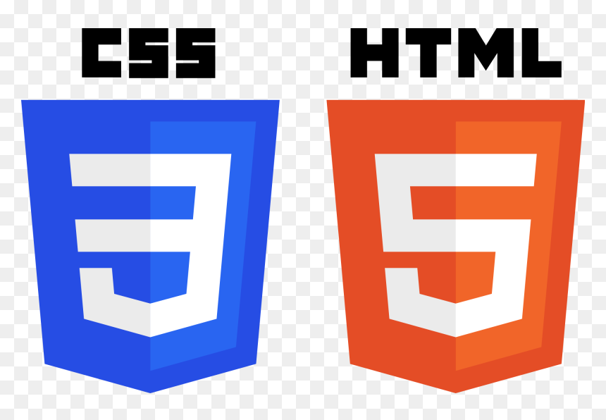
For the Front End, HTML (HyperText Markup Language) and CSS (Cascading Style Sheets) are used. HTML serves as the backbone for structuring the content on web pages, such as text, images, and forms. CSS complements HTML by defining the design and layout of these elements, ensuring the application has a visually appealing and responsive user interface. Together, HTML and CSS create the foundation for engaging and user-friendly front-end development.
BACKEND : PYTHON
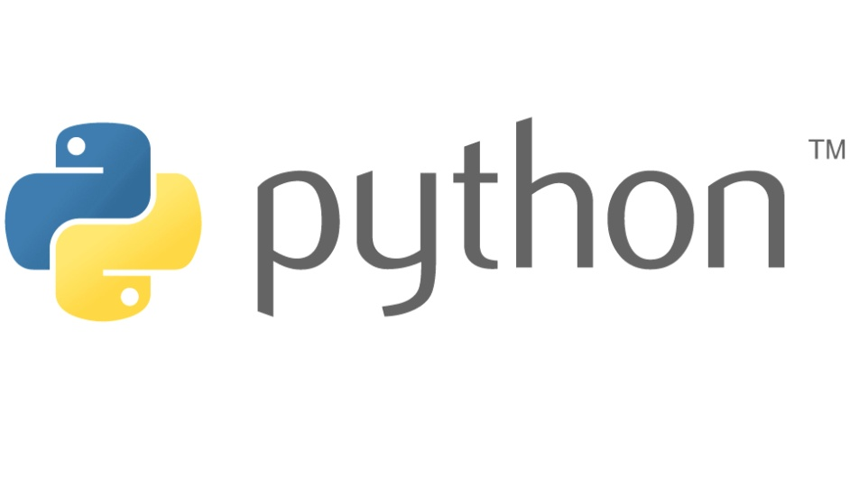
The Back End of the application is powered by Python, a versatile and beginner-friendly programming language known for its readability and extensive libraries. Python efficiently handles server-side operations, including data processing, database interactions, and executing business logic, making it a reliable choice for backend development.
FRAMEWORK : FLASK

To streamline the development process, the Flask framework is used. Flask is a lightweight and flexible Python web framework that allows developers to build web applications quickly and efficiently. Its minimalist nature makes it easy to add or remove features based on project requirements. Flask also supports integrations with databases, APIs, and other tools, enabling seamless full-stack development.

CHAPTER 4
SYSTEM DESIGN
4.1 DATA FLOW DIAGRAM
LEVEL 0:
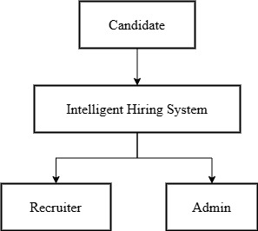
LEVEL 1:

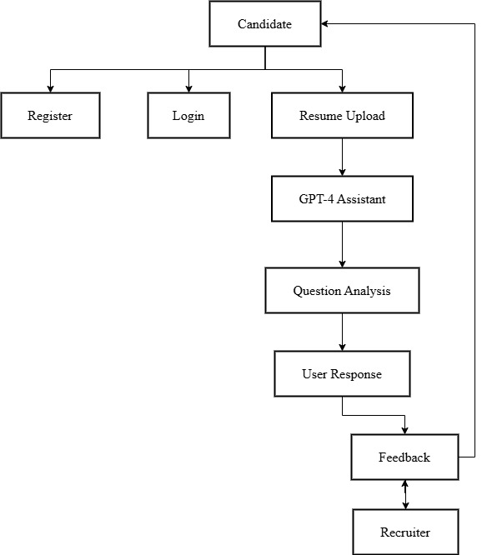
4.2 UML DIAGRAMS
4.2.1 USE CASE DIAGRAM
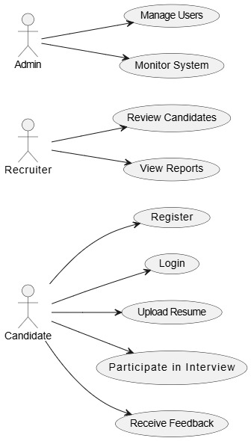

4.2.2 CLASS DIAGRAM
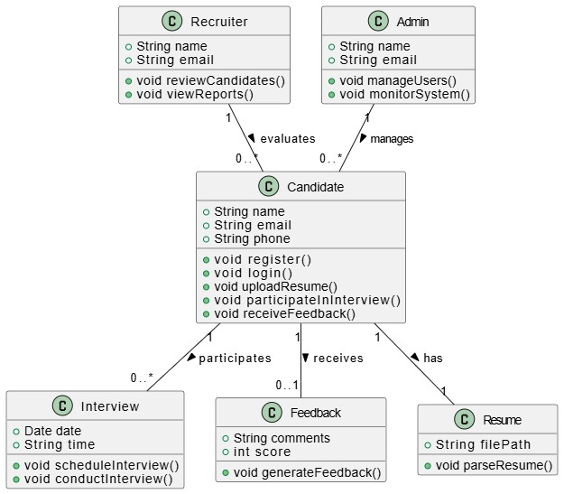

4.2.3 SEQUENCE DIAGRAM
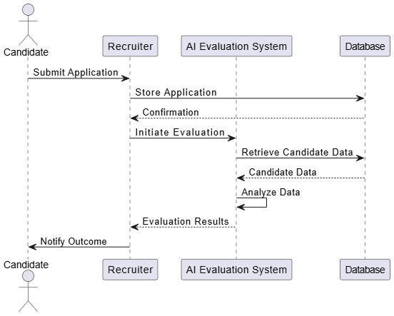

4.3.4 ACTIVITY DIAGRAM
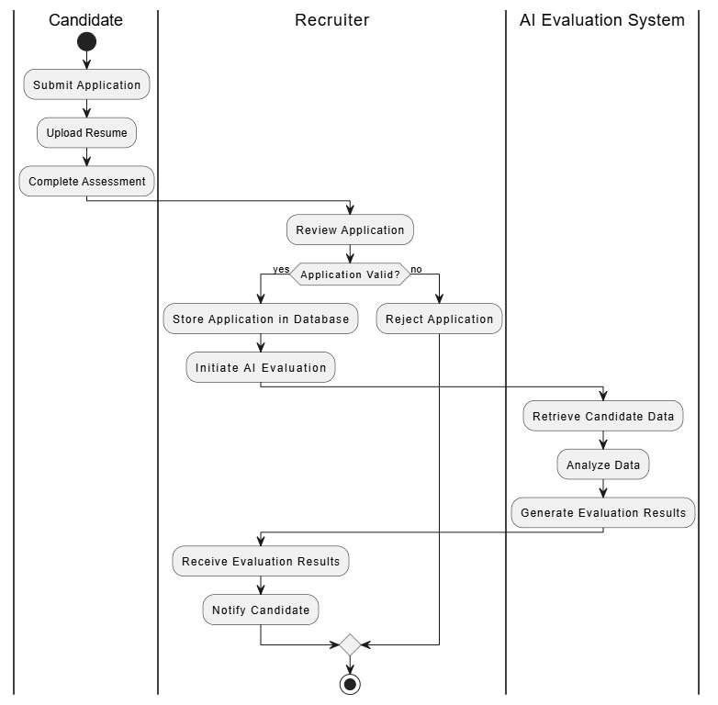

CHAPTER 5
SYSTEM ARCHITECTURE
5.1 SYSTEM ARCHITECTURE

REGISTER
LOGIN
RESUME UPLOAD
GPT-4
ASSISTANT
QUESTION ANALYSIS
USER RESPONSE
FEED BACK
USER

5.2 SYSTEM ARCHITECTURE DESCRIPTION
The process begins with REGISTER, where users create an account by providing necessary details such as name, email, and password. This step ensures secure access to the platform’s features. Once registered, users proceed to LOGIN, where they authenticate their identity to gain entry into their personalized dashboard.The next step, RESUME UPLOAD, allows users to submit their resumes. This is a critical phase, as the platform may use the uploaded resume for job applications, evaluations, or feedback. The system might parse the resume to extract key details like skills, experience, and qualifications.After the resume is processed, the platform generates a USER RESPONSE, which could include confirmation of successful upload, suggestions for improvements, or matches with job opportunities. This step ensures users are informed about the status of their submission.The QUESTION phase involves the platform posing queries to the user, possibly to clarify resume details, gather additional information, or assess suitability for specific roles. This interactive step enhances the platform’s understanding of the user’s profile.The GPT-4 label indicates the use of advanced AI technology, likely to analyze resumes, generate responses, or provide insights. GPT-4’s capabilities ensure accurate and efficient processing of user data.Finally, FED BACK refers to the feedback provided by the platform, which could include resume tips, job recommendations, or areas for improvement. This step closes the loop, offering users actionable insights to enhance their job-seeking efforts.
5.3 MODAL DESIGN
5.3.1 GPT-4 CLASSIFICATION
GPT-4 classification refers to the model's ability to categorize text into predefined classes or labels based on its understanding of language. This capability is particularly useful in various applications, such as sentiment analysis, topic categorization, and spam detection. By leveraging its advanced natural language processing skills, GPT-4 can accurately classify content, making it a valuable tool for businesses and researchers alike.In practice, classification can be performed using zero-shot or few-shot prompting. In zero-shot classification, users provide a prompt that outlines the classes without any examples, and GPT-4 determines the appropriate category based on its training.

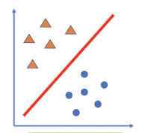
For instance, a user might ask the model to classify a review as positive, negative, or neutral. In few-shot classification, users include a few examples in the prompt to guide the model, enhancing its accuracy.Applications of GPT-4 classification are vast. Businesses can analyze customer feedback to gauge sentiment, while content creators can categorize articles or posts for better organization. Additionally, educational platforms can use classification to sort learning materials by subject or difficulty level. Overall, GPT-4's classification capabilities streamline processes, improve efficiency, and enhance the user experience across various domains.

CHAPTER 6
SYSTEM IMPLEMENTATION
6.1 MODULE LIST
- User Management Module
- Resume Processing Module
- AI Analysis Module
- Interview Module
- Biometric Verification Module
- Reporting Module
- Notification Module
- Admin Module

6.2 MODULE DESCRIPTION
User Management Module
The User Management Module is responsible for handling user accounts and permissions within the system. It allows administrators to create, update, and delete user profiles, ensuring that each user has appropriate access levels based on their roles. This module also includes features for password management, user authentication, and activity tracking, enhancing security and accountability. Additionally, it provides a user-friendly interface for users to manage their profiles, including personal information and preferences. By centralizing user data, this module facilitates efficient management and supports compliance with data protection regulations.
Resume Processing Module
The Resume Processing Module automates the extraction and analysis of candidate resumes submitted during the application process. Utilizing advanced parsing techniques, it identifies key information such as contact details, education, work experience, and skills. This module streamlines the recruitment process by converting unstructured resume data into structured formats that can be easily analyzed and compared. It also supports various file formats, ensuring compatibility with diverse resume submissions. By integrating with the AI Analysis Module, it enhances the overall evaluation process, allowing recruiters to quickly identify suitable candidates based on predefined criteria.
AI Analysis Module
The AI Analysis Module leverages machine learning algorithms to evaluate candidate profiles and resumes against job requirements. By analyzing various factors such as skills, experience, and cultural fit, this module provides insights into candidate suitability. It can also perform sentiment analysis on cover letters and other application materials to gauge a candidate's enthusiasm and alignment with company values. The AI Analysis Module continuously learns from past hiring decisions, improving its accuracy over time. This data-driven approach not only speeds up the selection process but also helps reduce bias, ensuring a fair evaluation of all candidates.

Interview Module
The Interview Module facilitates the scheduling, management, and evaluation of candidate interviews. It allows recruiters to set up interviews, send invitations, and manage calendars seamlessly. This module can support various interview formats, including in-person, phone, and video interviews, providing flexibility for both candidates and interviewers. Additionally, it includes features for interview feedback collection, enabling interviewers to rate candidates and provide comments. By centralizing interview data, this module helps streamline the decision-making process and ensures that all stakeholders have access to relevant information for evaluating candidates.
Biometric Verification Module
The Biometric Verification Module enhances security by implementing biometric authentication methods, such as fingerprint or facial recognition, for user access. This module ensures that only authorized personnel can access sensitive information and functionalities within the system. By integrating biometric technology, it reduces the risk of unauthorized access and enhances the overall security posture of the application. The module is designed to be user-friendly, allowing for quick and seamless verification processes. Additionally, it maintains a log of biometric access attempts, providing an audit trail for compliance and security monitoring.
Reporting Module
The Reporting Module provides comprehensive analytics and reporting capabilities for the recruitment process. It generates detailed reports on various metrics, such as candidate demographics, application statuses, and hiring timelines. This module allows administrators and recruiters to visualize data through charts and graphs, facilitating informed decision-making. Customizable reporting options enable users to focus on specific areas of interest, such as diversity metrics or interview performance. By consolidating data from different modules, the Reporting Module offers valuable insights into the effectiveness of recruitment strategies and helps identify areas for improvement.
Notification Module
The Notification Module ensures timely communication between the system and its users by sending alerts and updates regarding application statuses, interview schedules, and other important events. It supports various notification channels, including email, SMS, and in-app messages, allowing users to choose their preferred method of communication. This module enhances user engagement by keeping candidates informed throughout the recruitment process, reducing uncertainty and improving the overall experience. Additionally, it can be configured to send reminders for upcoming interviews or deadlines, ensuring that both candidates and recruiters stay on track.
Admin Module
The Admin Module serves as the control center for managing the entire recruitment system. It provides administrators with tools to configure system settings, manage user roles, and oversee module functionalities. This module allows for the monitoring of system performance, user activity, and data integrity, ensuring that the application runs smoothly. Administrators can also generate reports on system usage and performance metrics, helping to identify areas for optimization. By centralizing administrative tasks, this module enhances operational efficiency and ensures that the recruitment process aligns with organizational goals and compliance requirements.

CHAPTER 7
SYSTEM TESTING
7.1 TESTING OBJECTIVE
Accuracy of Assessments: Ensure that the AI algorithms accurately evaluate candidate skills and qualifications based on predefined criteria. This involves testing the system's ability to correctly interpret and analyze resumes, interview responses, and other application materials.
Bias Reduction Validation: Assess the effectiveness of AI tools in minimizing bias during candidate evaluations. This includes testing for fairness in the selection process and ensuring that the algorithms do not favor specific demographics or backgrounds.
Data Processing Reliability: Confirm that the system processes and analyzes candidate data consistently and reliably. This involves testing the integration of various modules, such as resume processing and AI analysis, to ensure seamless data flow and accurate results.
User Experience Evaluation: Evaluate the user interface and overall experience for both candidates and recruiters. This includes testing the ease of navigation, clarity of communication, and responsiveness of the system to user inputs.
System Performance Under Load: Test the platform's performance under various loads to ensure it can handle a high volume of applications and user interactions without degradation in speed or functionality.
Compliance with Data Protection Regulations: Verify that the system adheres to relevant data protection laws and regulations, ensuring that candidate information is securely stored and processed. This includes testing for proper consent mechanisms and data encryption practices.
Feedback Mechanism Effectiveness: Assess the functionality of feedback collection features within the interview module. This involves testing how well interviewers can provide and access feedback on candidates, ensuring that it contributes to informed decision-making.
Integration Testing: Ensure that all modules work together seamlessly, from user management to reporting. This includes testing the interactions between different components of the system to confirm that data is accurately shared and utilized across the platform.
7.2 TESTING METHOD
Unit Testing
Unit testing focuses on verifying the smallest components of the software, such as individual functions or methods, to ensure they perform as expected. Each module, such as the Resume Processing Module or the AI Analysis Module, is tested in isolation to confirm that specific functionalities work correctly. Test cases are designed to cover various scenarios, including edge cases and error conditions. By identifying and fixing issues at this granular level, unit testing helps maintain code quality and facilitates easier debugging during the development process.
Integration Testing
Integration testing evaluates the interactions between different modules within the system to ensure they work together seamlessly. This method focuses on the data flow and communication between components, such as how the User Management Module interacts with the Interview Module. Test cases are designed to verify that data is correctly passed between modules and that combined functionalities produce the expected outcomes. By identifying integration issues early, this testing method helps ensure that the overall system functions cohesively and meets user requirements.
Functional Testing
Functional testing assesses the system's functionalities against specified requirements. This method involves testing the application from the user's perspective to ensure that all features, such as candidate evaluations and reporting, work as intended. Test cases are derived from user stories and business requirements, covering both positive and negative scenarios. By validating that the system behaves as expected in real-world situations, functional testing ensures that the application meets user needs and provides a satisfactory experience.
White Box Testing
White box testing involves examining the internal logic and structure of the code. Testers have access to the source code and design test cases based on the code's implementation. This method is particularly useful for identifying logical errors, security vulnerabilities, and performance issues within individual functions or algorithms, such as those used in the AI Analysis Module. By focusing on the internal workings of the application, white box testing helps ensure that the code is efficient, secure, and free of defects.
Black Box Testing
Black box testing evaluates the system's functionality without knowledge of its internal code structure. Testers focus on input and output, assessing whether the application meets specified requirements and behaves as expected. This method is particularly effective for functional and acceptance testing, as it simulates real user interactions with the system. By concentrating on the user experience and outcomes, black box testing helps ensure that the application delivers the desired results and meets user expectations, regardless of how the underlying code is implemented.

CHAPTER 8
CONCLUSION AND FUTURE ENHANCEMENT

8.1 CONCLUSION
The AI-powered recruitment platform represents a significant advancement in the hiring landscape, transforming traditional recruitment methods into a streamlined, efficient process. By integrating automated resume analysis, intelligent questioning, and biometric verification, this platform offers a comprehensive solution for candidate evaluation that prioritizes security and efficiency. The use of advanced technologies, such as GPT-4 for dynamic question-and-answer interactions, allows for a more engaging and responsive candidate experience. This not only enhances the quality of interactions but also ensures that candidates are assessed in a manner that is both accurate and free from bias.One of the standout features of this platform is its real-time facial recognition capability, which serves as a robust fraud detection mechanism. This ensures that the integrity of the hiring process is maintained, as it helps to verify the identity of candidates during interviews. By significantly reducing the time required for screening, the platform allows recruiters to focus on what truly matters—finding the right talent for their organizations.Moreover, the adaptive feedback mechanism fosters greater candidate engagement by providing timely and constructive insights throughout the application process. Automated alerts keep recruiters informed with actionable insights, enabling them to make informed decisions quickly. This end-to-end solution effectively addresses critical challenges faced in modern recruitment, including scalability, security, and objectivity.Ideal for enterprises, educational institutions, and certification bodies, this platform sets a new standard for fast, fair, and fraud-resistant hiring processes. By leveraging AI-driven automation and robust verification methods, it not only enhances the efficiency of recruitment but also ensures that the process is equitable for all candidates. As organizations continue to seek innovative solutions to improve their hiring practices, this platform stands out as a pioneering tool that meets the demands of today’s competitive job market.

8.2 FUTURE ENHANCEMENT
The AI recruitment platform holds significant promise for future enhancements that can further revolutionize the hiring process. One of the most exciting avenues for expansion is the integration of automated skill validation through partnerships with coding simulators and Learning Management Systems (LMS). This would allow employers to assess candidates' technical abilities in real-time, ensuring that applicants possess the necessary skills for the roles they are applying for. By providing a more comprehensive evaluation of candidates, organizations can make more informed hiring decisions.Future iterations of the platform could also incorporate advanced voice and video analytics to assess candidates' communication skills and emotional intelligence. These features would enable recruiters to gain deeper insights into how candidates express themselves and interact in various scenarios, which is particularly valuable in roles that require strong interpersonal skills. Additionally, with the rise of multimodal AI, the platform could leverage virtual reality (VR) to conduct situational tests, immersing candidates in realistic scenarios that simulate job-related challenges.As regulations around data privacy and security evolve, integrating blockchain technology could provide a robust solution for tamper-proof credential verification. This would enhance trust in the hiring process, allowing employers to verify candidates' qualifications and backgrounds with confidence.The increasing demand for remote hiring tools positions this AI recruitment solution for global scalability, especially in the technology and Business Process Outsourcing (BPO) sectors. However, as the platform expands, it is crucial to prioritize ethical AI practices and bias mitigation to ensure fair treatment of diverse candidate pools. Establishing strategic partnerships with HR tech providers can accelerate market adoption and enhance the platform's capabilities, ultimately leading to a more efficient and equitable hiring landscape. By embracing these enhancements, the platform can continue to set new standards in recruitment technology.

APPENDICES
A. SOURCE CODE
import asyncio
from asyncio import WindowsSelectorEventLoopPolicy
from flask import Flask, render_template, request, jsonify, session, redirect, url_for, flash
import g4f
import PyPDF2
import os
import json
import re
from werkzeug.security import generate_password_hash, check_password_hash
from datetime import timedelta

# Set the event loop policy for Windows (if applicable)
asyncio.set_event_loop_policy(WindowsSelectorEventLoopPolicy())

app = Flask(_name_)
app.secret_key = "supersecretkey" # Change this to a secure random key in production
app.permanent_session_lifetime = timedelta(days=1) # Session lasts 1 day

# Path to JSON database
USERS_DB = "users.json"

# Initialize users.json if it doesn't exist
if not os.path.exists(USERS_DB):
with open(USERS_DB, "w") as f:
json.dump({}, f)

# Store resume content and interview state
resume_content = ""
interview_state = {
"stage": "initial",
"skills": [],
"questions_per_skill": {},
"total_questions_asked": 0,
"responses": []
}

def load_users():
"""Load users from JSON file."""
with open(USERS_DB, "r") as f:
return json.load(f)

def save_users(users):
"""Save users to JSON file."""
with open(USERS_DB, "w") as f:
json.dump(users, f, indent=4)

def extract_text_from_pdf(file):
"""Extract text from a PDF file."""
try:
pdf_reader = PyPDF2.PdfReader(file)
text = ""
for page in pdf_reader.pages:
text += page.extract_text() or ""
return text
except Exception as e:
return f"Error extracting text from PDF: {e}"

def analyze_resume(document_content):
global resume_content, interview_state
resume_content = document_content
interview_state["stage"] = "analysis"
# ... (rest of the analyze_resume function remains the same)
try:
messages = [
{
"role": "system",
"content": (
"You are an AI Job Interview Simulator. Analyze the resume and return your answer strictly in JSON format. "
"Your output must be a valid JSON object with the following keys: "
"acknowledgment (a string message acknowledging the resume upload), "
"key_skills (an array of the top 5 skills), and "
"prompt (a string message to prompt the interview). "
"Do not include any extra text or markdown formatting."
)
},
{"role": "user", "content": f"Analyze this resume:\n\n{document_content}"}
]
response = g4f.ChatCompletion.create(
model="gpt-4o-mini",
messages=messages,
temperature=0.7,
top_p=0.9
)

json_match = re.search(r"\{.*\}", response, re.DOTALL)
if not json_match:
return "Error: The AI response did not contain valid JSON. Please try again or adjust your prompt."

json_str = json_match.group()
try:
data = json.loads(json_str)
except json.JSONDecodeError as json_err:
return f"Error parsing JSON: {json_err}"

skills = data.get("key_skills", [])
interview_state["skills"] = skills[:5] if skills else []
interview_state["questions_per_skill"] = {skill: 0 for skill in interview_state["skills"]}

formatted_skills = "\n".join([f"- {skill}" for skill in interview_state["skills"]])
final_response = (
f"{data.get('acknowledgment', 'Thank you for uploading your resume.')}\n\n"
f"*Key Skills*:\n{formatted_skills}\n\n"
f"{data.get('prompt', 'Please type \"start\" to begin the interview.')}"
)
return final_response.strip() if final_response else "Sorry, I couldn't process the resume."
except Exception as e:
return f"Error: {e}"

def generate_interview_question():
# ... (unchanged)
global interview_state
if not interview_state["skills"]:
return "No skills were identified from your resume. Please upload a more detailed resume to continue the interview."

total_questions_possible = len(interview_state["skills"]) * 1
if interview_state["total_questions_asked"] >= total_questions_possible:
return generate_feedback()

for skill in interview_state["skills"]:
if interview_state["questions_per_skill"][skill] < 1:
try:
messages = [
{
"role": "system",
"content": (
"You are an AI Job Interview Simulator conducting a real-time interview. "
"Generate one thoughtful, job-relevant question based on the skill provided. "
"Keep it concise, professional, and conversational."
)
},
{"role": "user", "content": f"Generate a question for the skill: {skill}"}
]
response = g4f.ChatCompletion.create(
model="gpt-4o-mini",
messages=messages,
temperature=0.7,
top_p=0.9
)
interview_state["questions_per_skill"][skill] += 1
interview_state["total_questions_asked"] += 1
return response.strip() if response else f"Tell me about your experience with {skill}."
except Exception as e:
return f"Error generating question: {e}"
return "Unexpected error in question generation."

def generate_feedback():
# ... (unchanged)
global interview_state
try:
messages = [
{
"role": "system",
"content": (
"You are an AI Job Interview Simulator. Based on the user's responses to interview questions, "
"provide feedback in a structured format: "
"- Start with a positive acknowledgment of their participation. "
"- *Strengths*: Highlight what they did well (e.g., clarity, confidence). "
"- *Weaknesses*: Note areas for improvement (e.g., detail, specificity). "
"- *Areas for Improvement*: Suggest specific ways to enhance their responses. "
"Use the responses provided and keep the tone constructive and encouraging."
)
},
{"role": "user", "content": f"Responses:\n\n{chr(10).join(interview_state['responses'])}"}
]
response = g4f.ChatCompletion.create(
model="gpt-4o-mini",
messages=messages,
temperature=0.7,
top_p=0.9
)
interview_state["stage"] = "completed"
return response.strip() if response else "Feedback could not be generated."
except Exception as e:
return f"Error: {e}"

def handle_user_response(user_input):
# ... (unchanged)
global interview_state
if interview_state["stage"] == "initial":
return "Please upload your resume to begin the interview simulation!"
elif interview_state["stage"] == "analysis":
if user_input.lower().strip() in ["start", "begin", "yes"]:
interview_state["stage"] = "interview"
return generate_interview_question()
return "Please confirm to start the interview (e.g., 'start' or 'yes')."
elif interview_state["stage"] == "interview":
interview_state["responses"].append(user_input)
return generate_interview_question()
elif interview_state["stage"] == "completed":
return "The interview is complete! You can upload a new resume to start again."
return "Something went wrong. Please try again."

@app.route("/")
def landing():
return render_template("landing.html")

@app.route("/register", methods=["GET", "POST"])
def register():
if request.method == "POST":
username = request.form.get("username")
password = request.form.get("password")
if not username or not password:
flash("Username and password are required!", "error")
return redirect(url_for("register"))

users = load_users()
if username in users:
flash("Username already exists!", "error")
return redirect(url_for("register"))

users[username] = {"password": generate_password_hash(password)}
save_users(users)
flash("Registration successful! Please log in.", "success")
return redirect(url_for("login"))
return render_template("register.html")

@app.route("/login", methods=["GET", "POST"])
def login():
if request.method == "POST":
username = request.form.get("username")
password = request.form.get("password")
users = load_users()

if username in users and check_password_hash(users[username]["password"], password):
session.permanent = True
session["username"] = username
flash("Logged in successfully!", "success")
return redirect(url_for("index"))
else:
flash("Invalid username or password!", "error")
return redirect(url_for("login"))
return render_template("login.html")

@app.route("/logout")
def logout():
session.pop("username", None)
flash("Logged out successfully!", "success")
return redirect(url_for("landing"))

@app.route("/interview")
def index():
if "username" not in session:
flash("Please log in to access the interview simulator.", "error")
return redirect(url_for("login"))
return render_template("index.html")

@app.route("/chat", methods=["POST"])
def chat():
if "username" not in session:
return jsonify({"response": "Please log in to continue."}), 401
data = request.get_json()
user_input = data.get("message", "")
response = handle_user_response(user_input)
return jsonify({"response": response})

@app.route("/upload", methods=["POST"])
def upload():
if "username" not in session:
return jsonify({"response": "Please log in to upload a resume."}), 401
# ... (rest of the upload function remains the same)
global interview_state
if "file" not in request.files:
return jsonify({"response": "No file uploaded."}), 400
file = request.files["file"]
if file.filename == "":
return jsonify({"response": "No file selected."}), 400

if file.filename.endswith(".pdf"):
document_content = extract_text_from_pdf(file)
elif file.filename.endswith(".txt"):
document_content = file.read().decode("utf-8")
else:
return jsonify({"response": "Unsupported file format. Please upload a PDF or text file."}), 400

if "Error" in document_content:
return jsonify({"response": document_content}), 500

interview_state = {
"stage": "initial",
"skills": [],
"questions_per_skill": {},
"total_questions_asked": 0,
"responses": []
}
response = analyze_resume(document_content)
return jsonify({"response": response})

if _name_ == "_main_":
app.run(debug=True)

B. SCREEN SHOTS
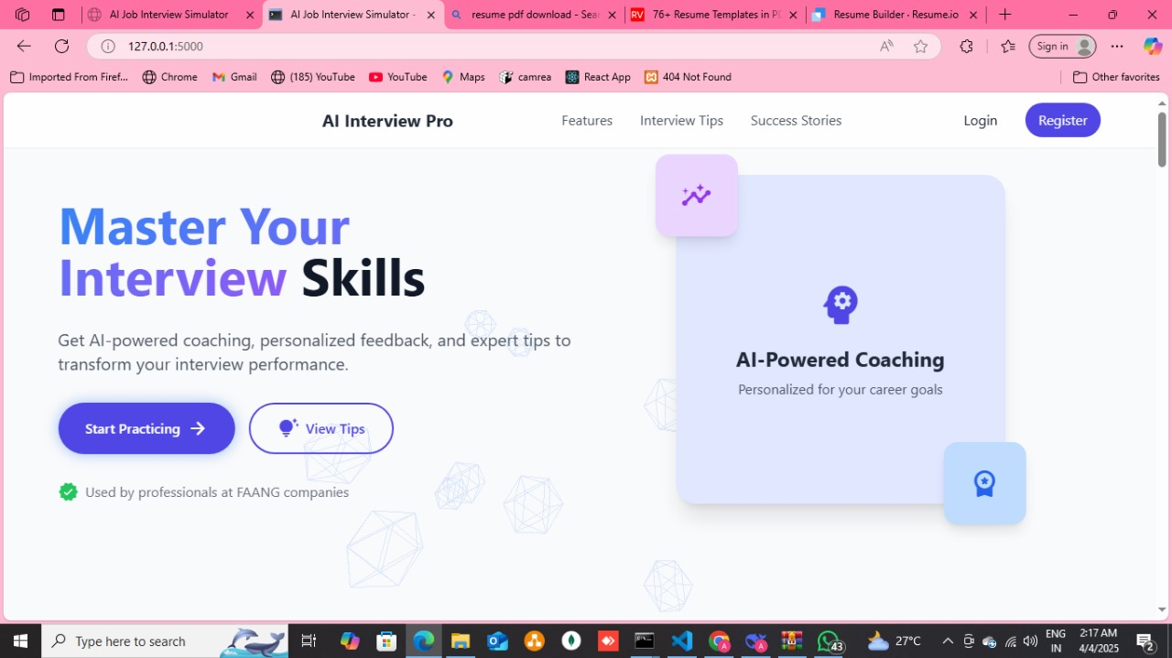

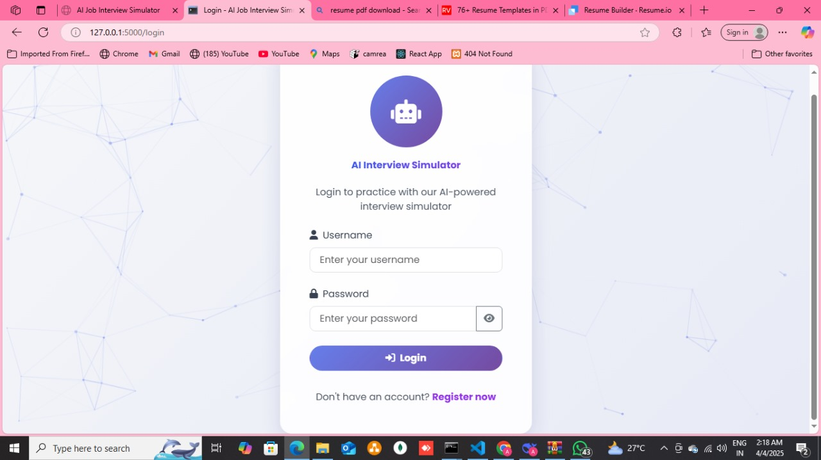

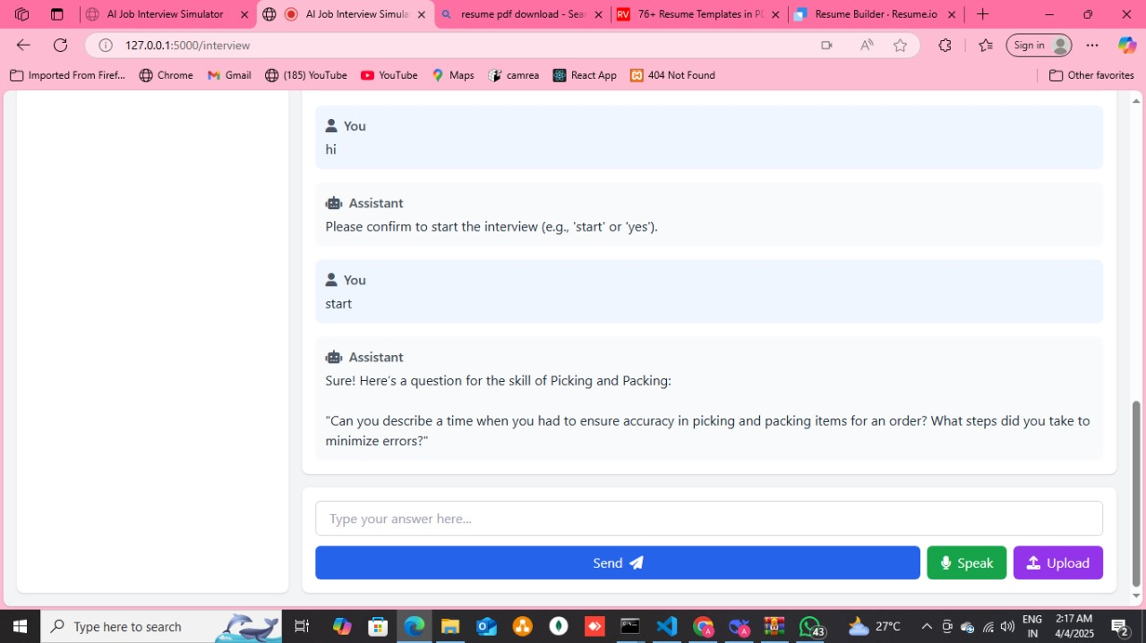

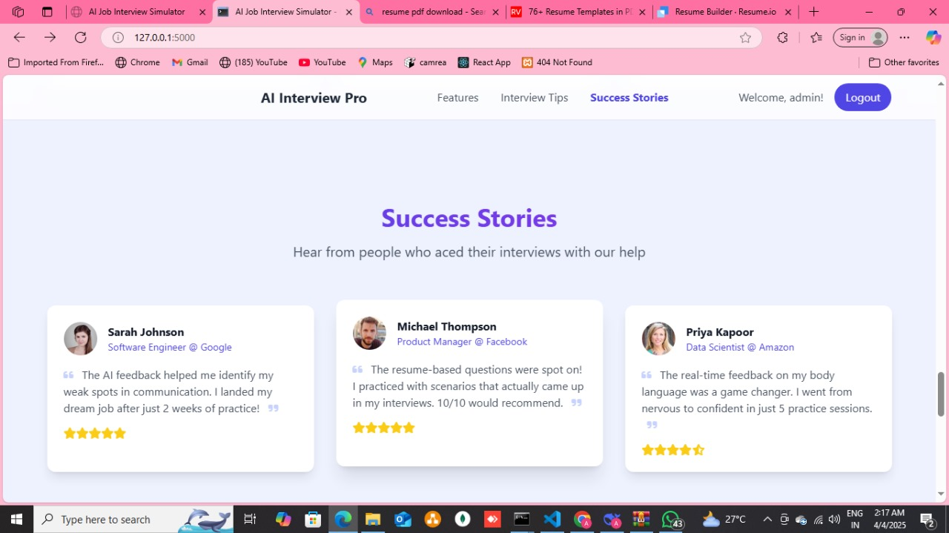

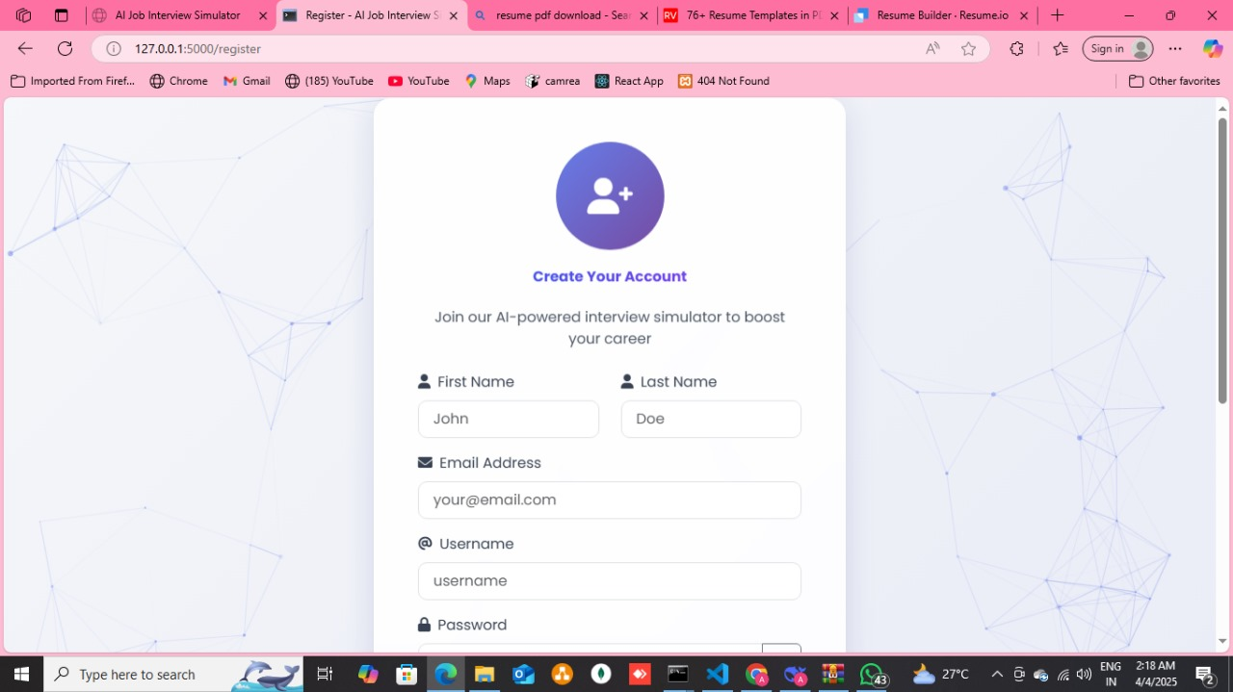

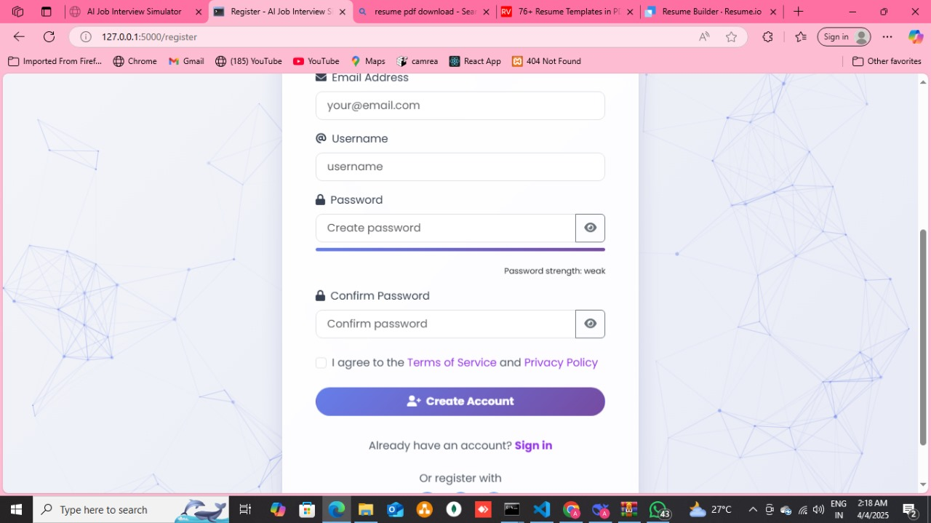

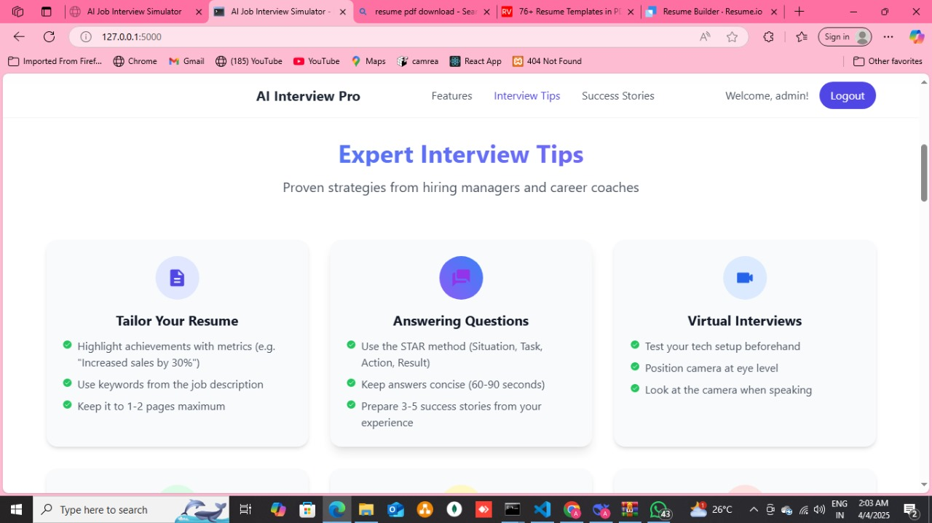

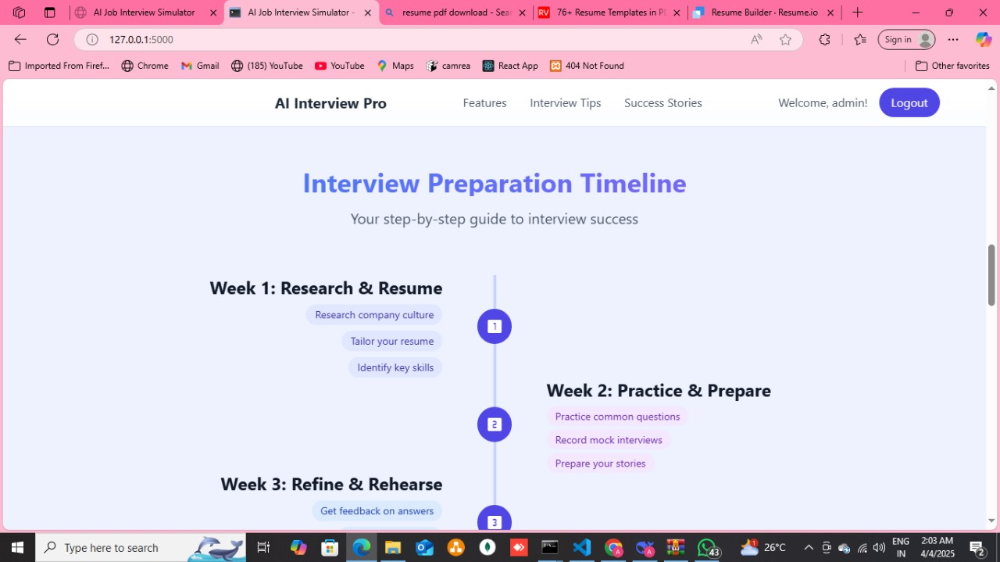

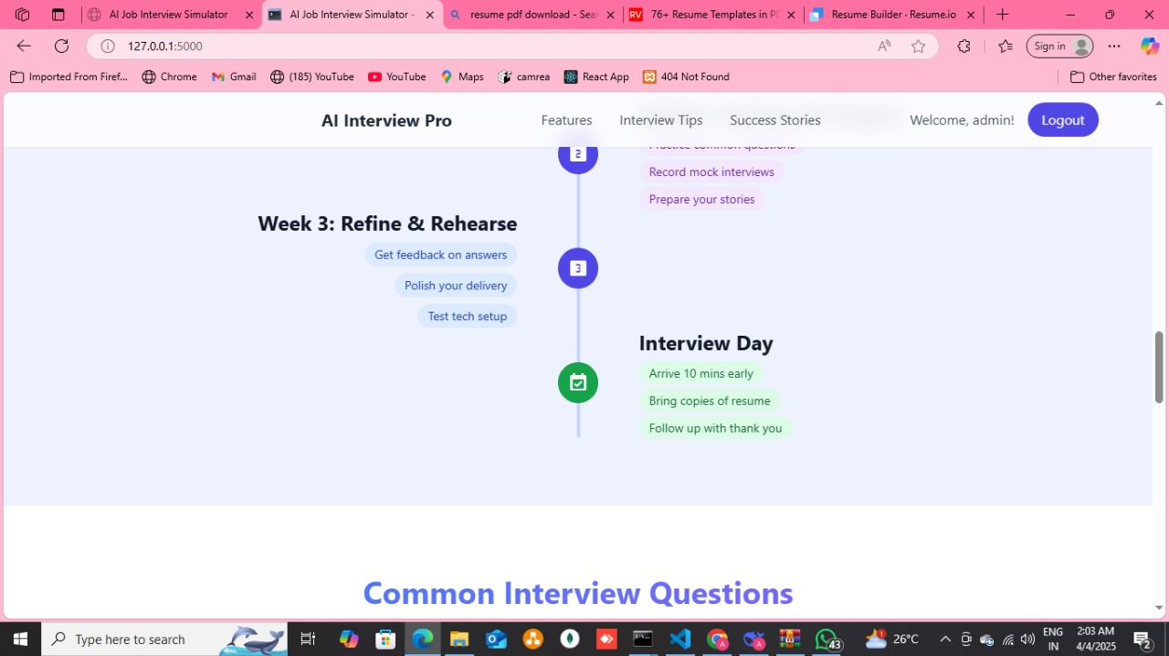

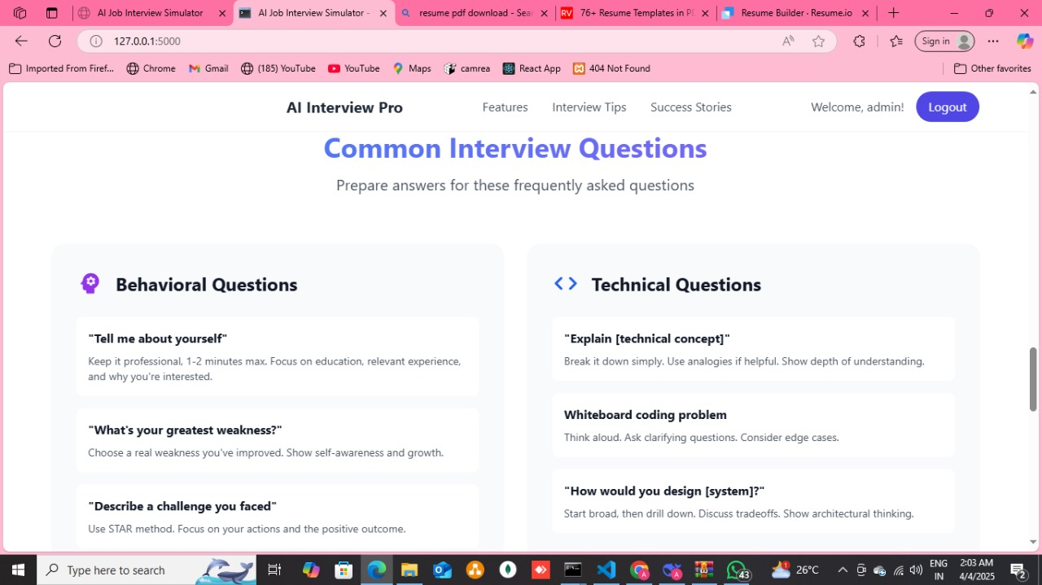

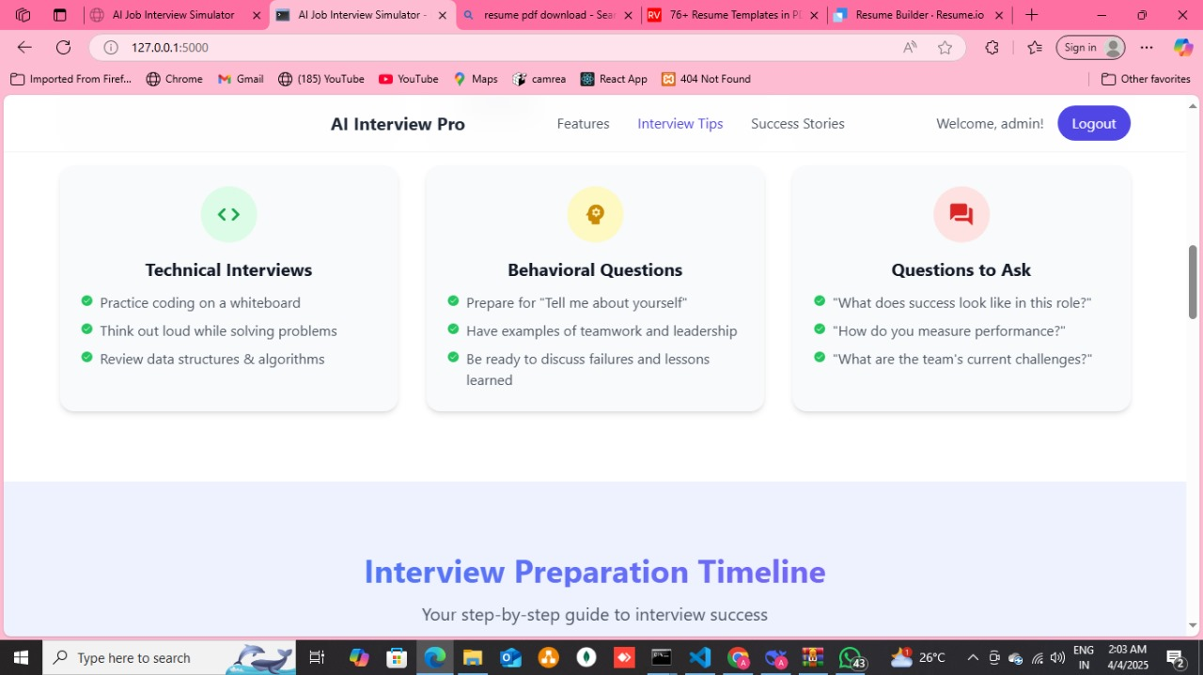

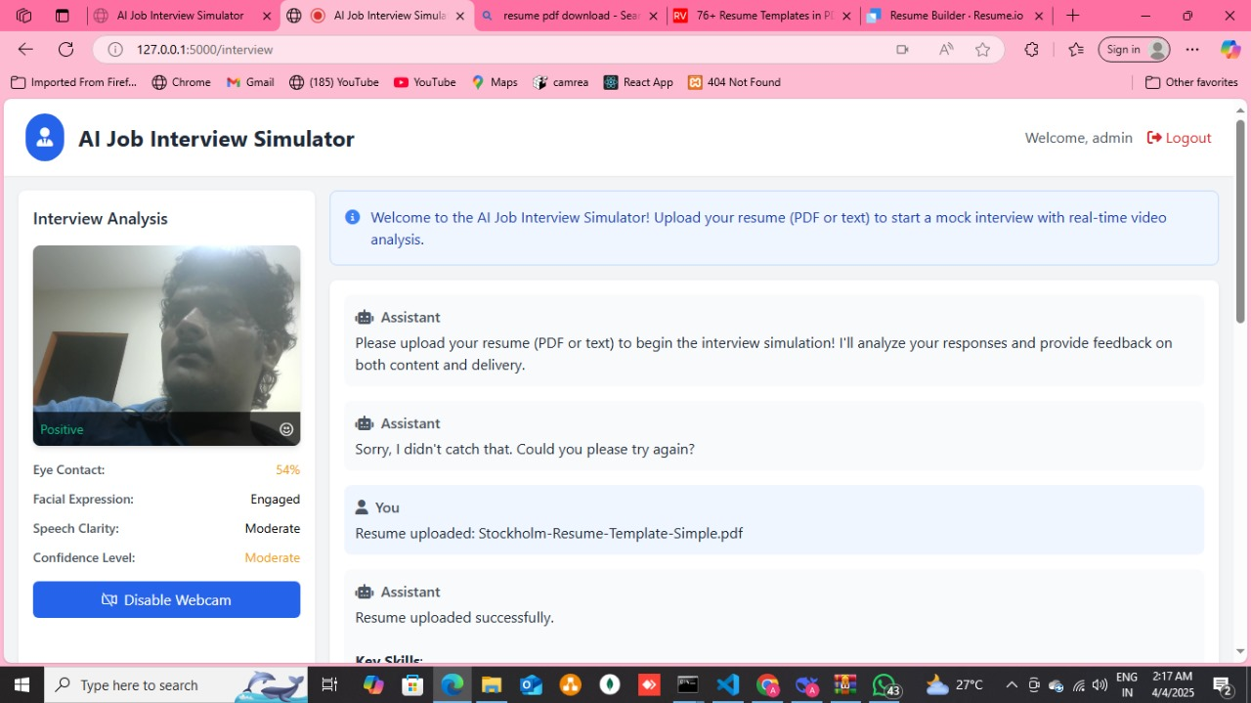

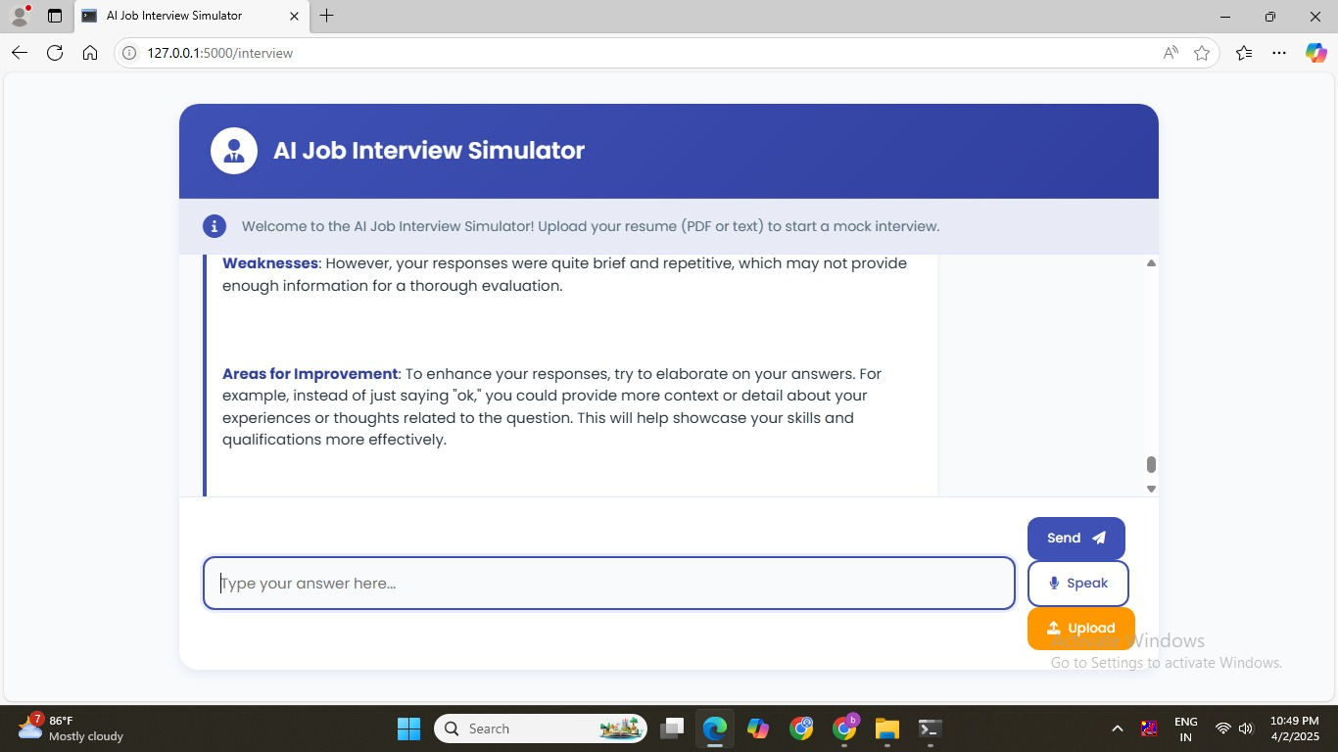

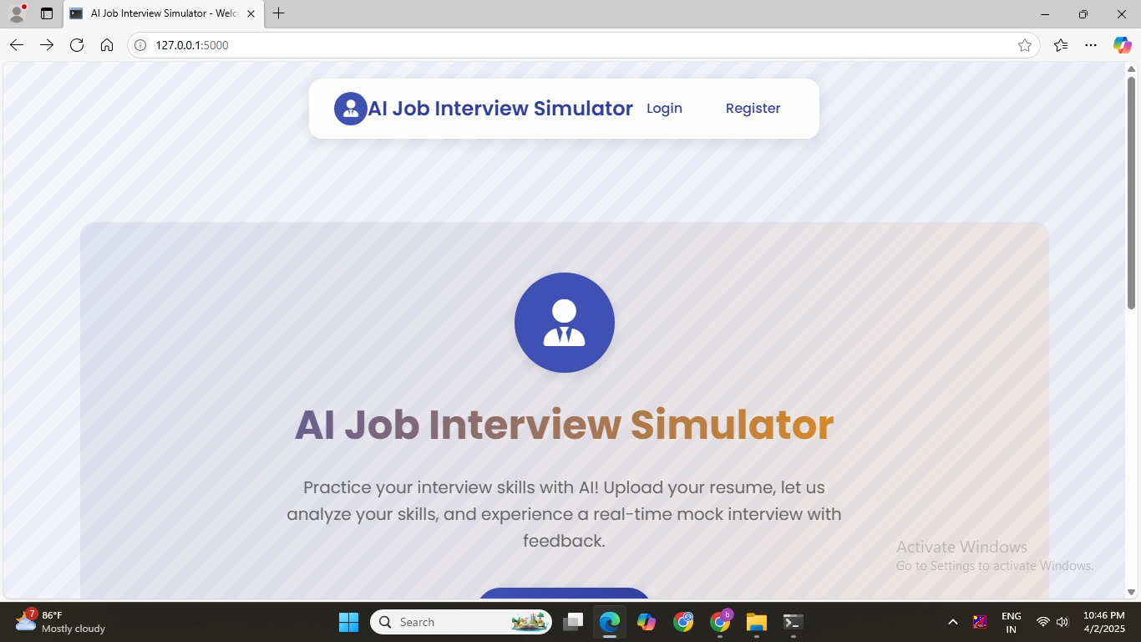

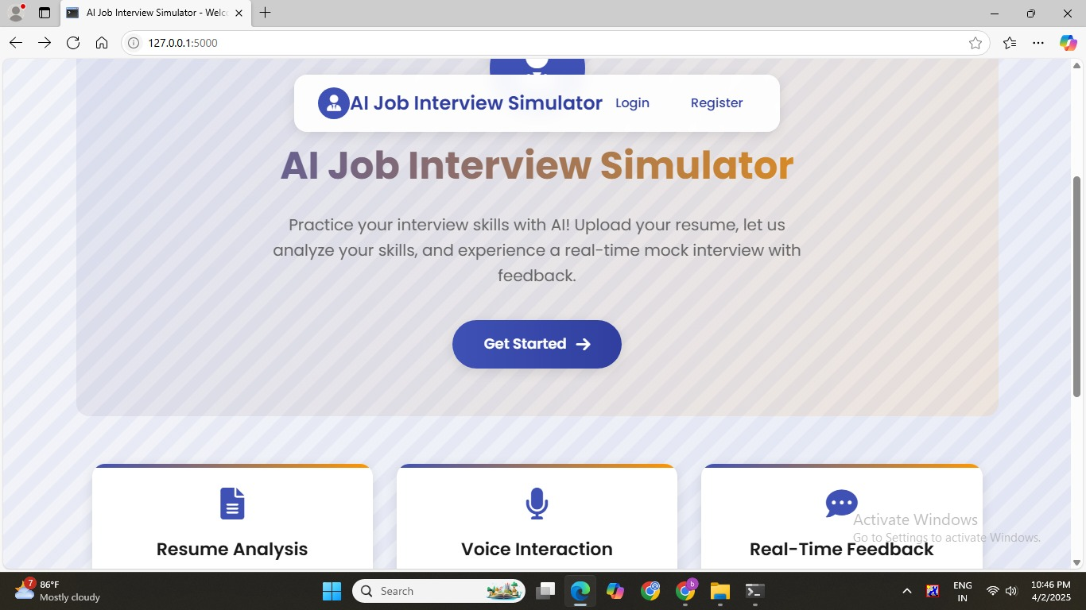

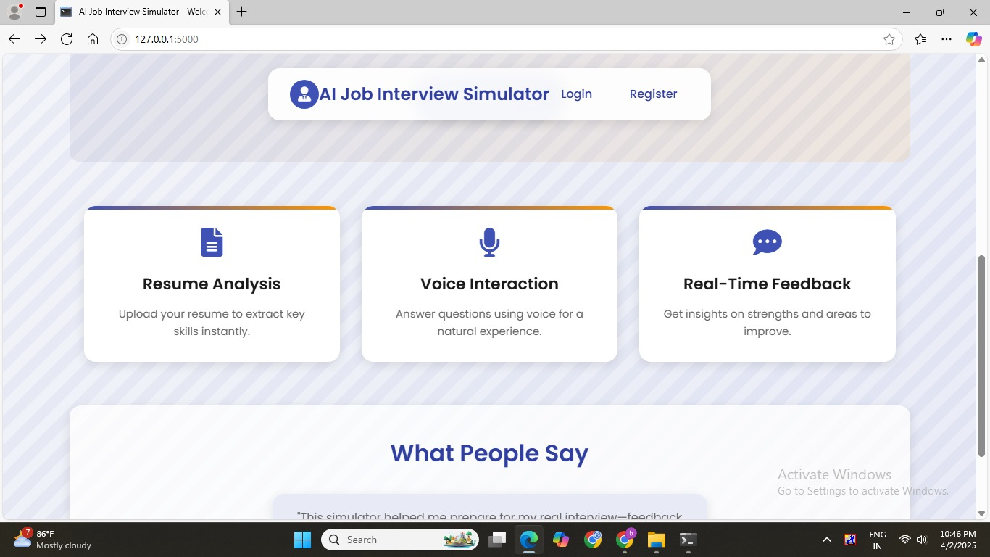

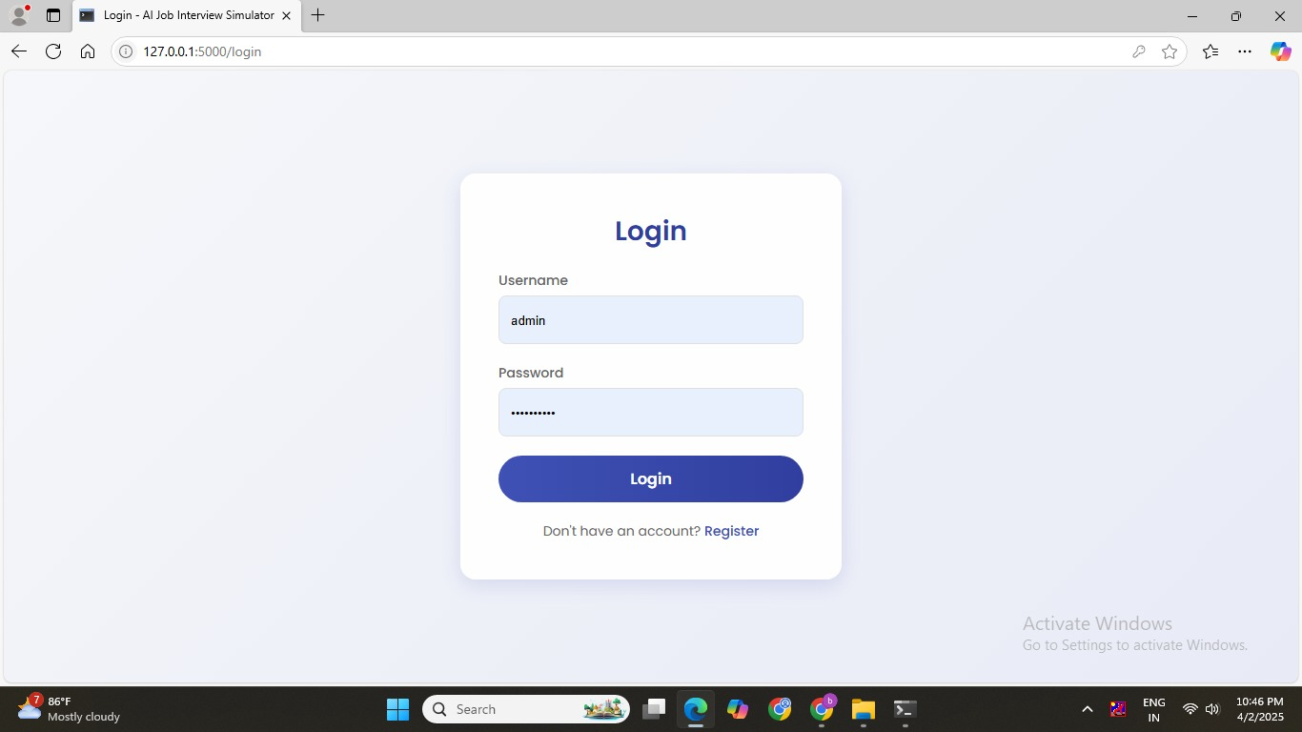

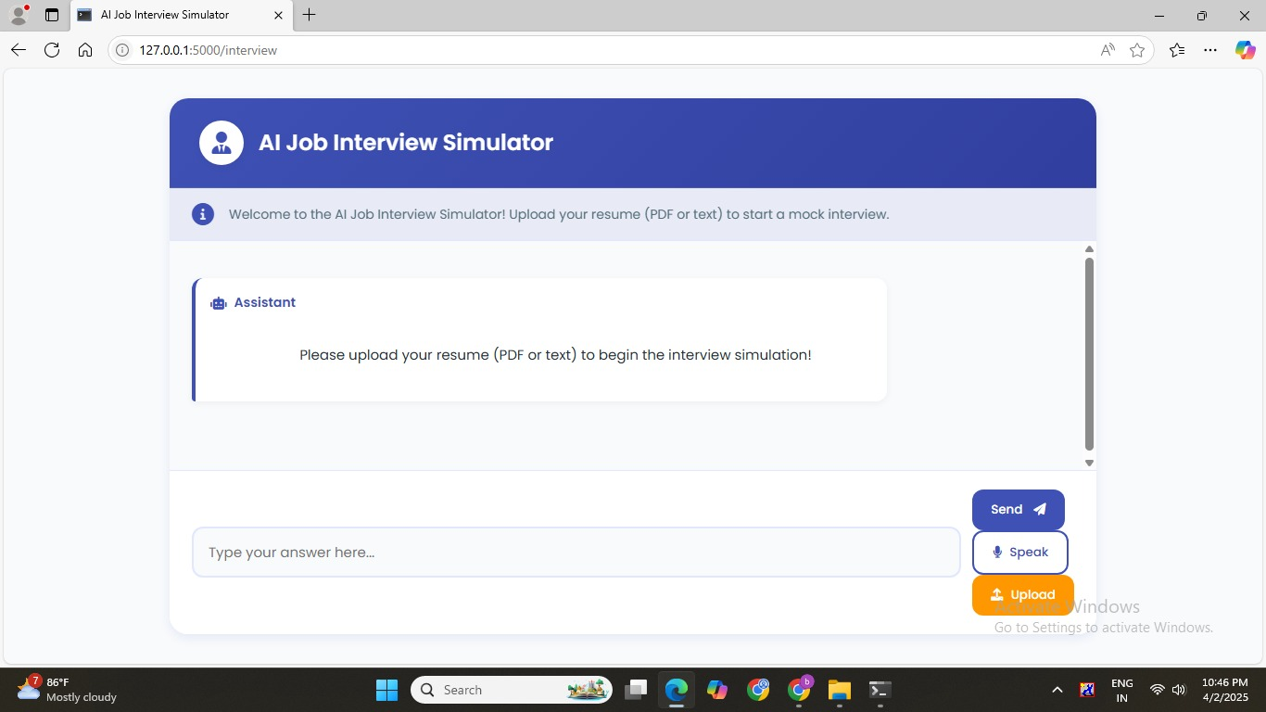

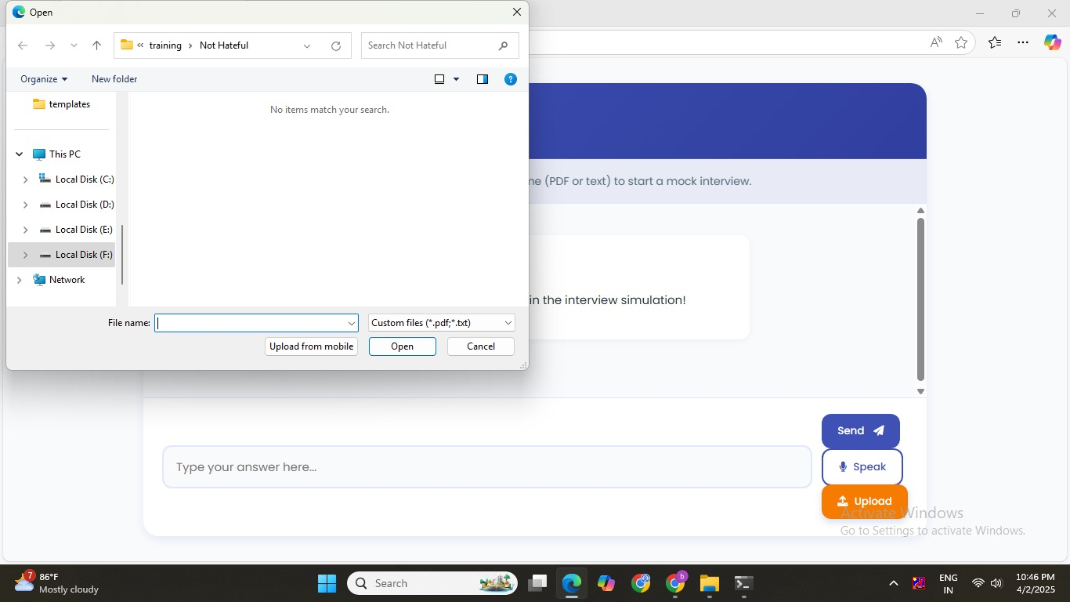

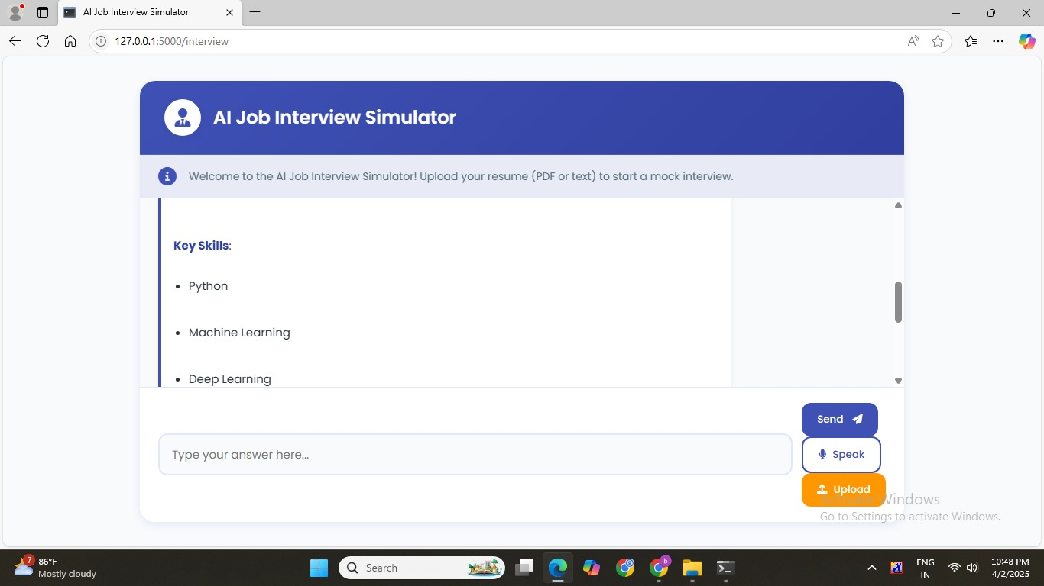

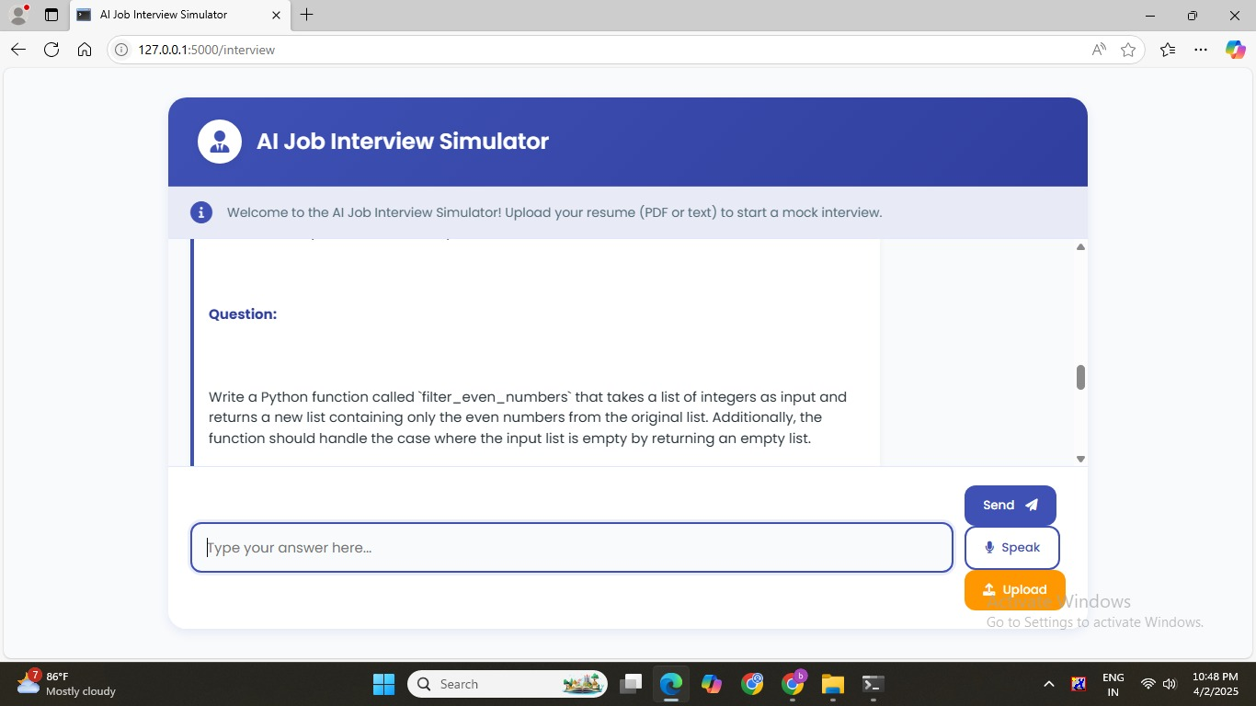

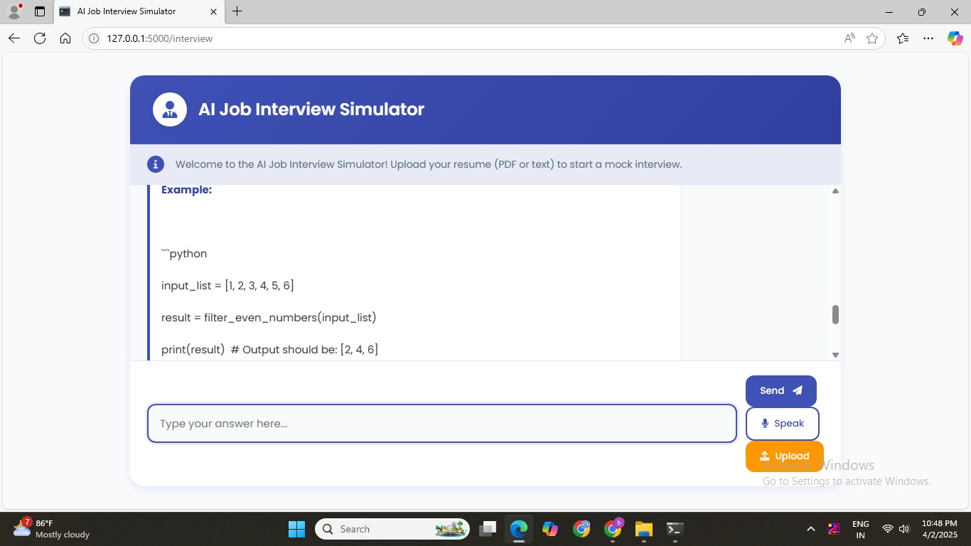

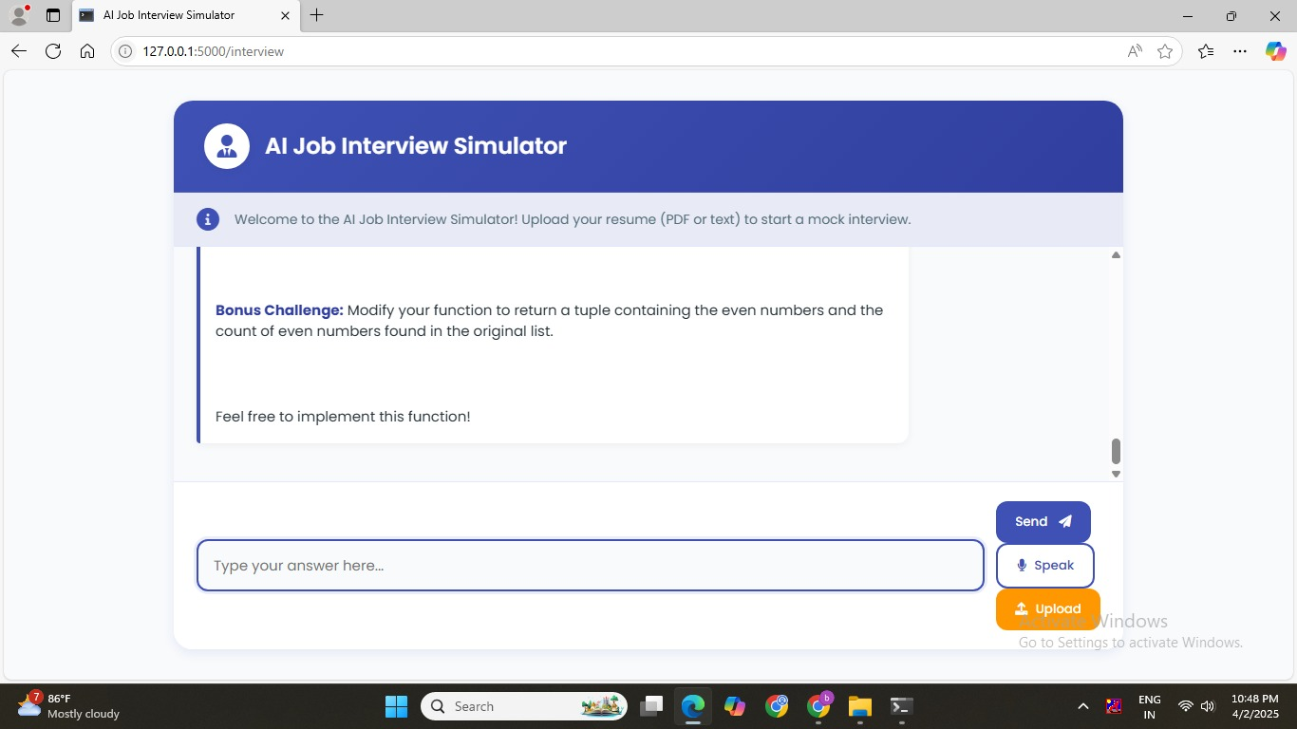

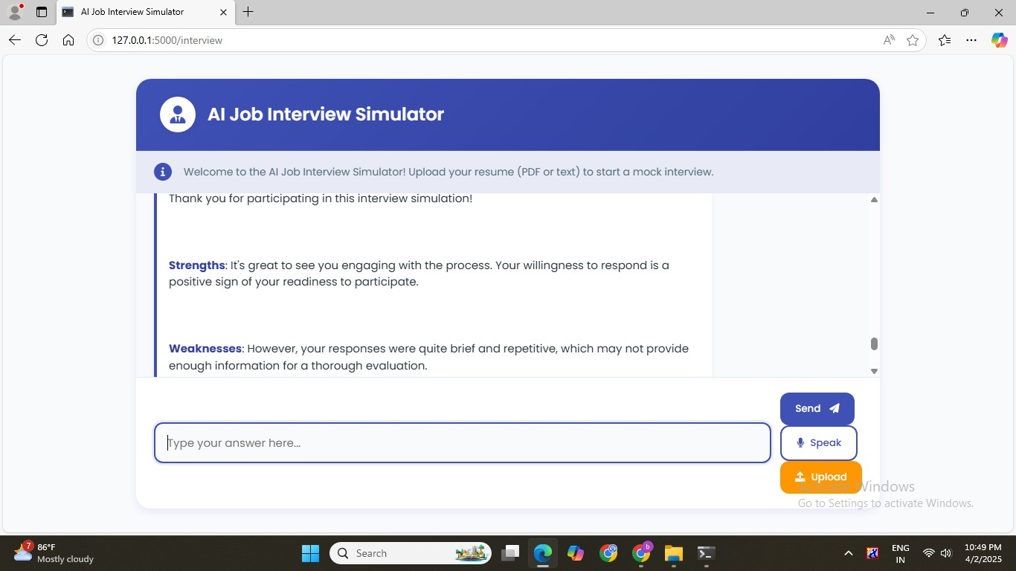

REFERENCE
- Si, J., Song, J., Woo, M., Kim, D., Lee, Y., & Kim, S. (2023). Generative AI Models for Virtual Interviewers: Applicability and Performance Comparison. IEEE International Conference on Innovation, Communication and Engineering.
- Swaraj, G., Kumar, B. N., Himavanth, B., Reddy, S. P., Anoop, S., & Jayasree, K. R. (2023). An Interactive Interview Bot for Human Resource Interviewing. 14th International Conference on Computing Communication and Networking Technologies (ICCCNT).
- Dissanayake, D. Y., Amalya, V., Dissanayaka, R., Lakshan, L., Samarasinghe, P., Nadeeshani, M., & Samarasinghe, P. (2021). AI-based Behavioural Analyser for Interviews/Viva. 16th International Conference on Industrial and Information Systems (ICIIS).
- Jin, X., Bian, Y., Geng, W., Chen, Y., Chu, K., Hu, H., Liu, J., Shi, Y., & Yang, C. (2019). Developing an Agent-based Virtual Interview Training System for College Students with High Shyness Level. IEEE Conference on Virtual Reality and 3D User Interfaces.
- Suen, H. Y., Hung, K. E., & Lin, C. L. (2019). TensorFlow-based Automatic Personality Recognition Used in Asynchronous Video Interviews. IEEE Access, 7, 61018–61023.
- Zhang, H., Jolfaei, A., & Alazab, M. (2019). A Face Emotion Recognition Method Using Convolutional Neural Network and Image Edge Computing. IEEE Access, 7, 159081–159089.
- Suen, H. Y., Hung, K. E., & Lin, C. L. (2019). Chatbot Use Intention Analysis: A Personality Perspective. IEEE Access, 7, 153932–153940.
- Suen, H. Y., Hung, K. E., & Lin, C. L. (2019). A Large-Scale Study on the Personality Traits and Interview Performance of Job Candidates. IEEE Access, 7, 116645–116656.
- Suen, H. Y., Hung, K. E., & Lin, C. L. (2019). An Empirical Study on the Effect of Personality Traits on Job Interview Performance. IEEE Access, 7, 116657–116668.
- Suen, H. Y., Hung, K. E., & Lin, C. L. (2019). A Study on the Effect of Personality Traits on Job Interview Performance Using Machine Learning. IEEE Access, 7, 116669–116680.

